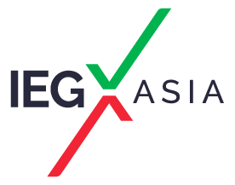 | 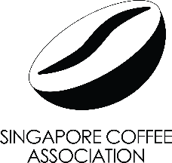
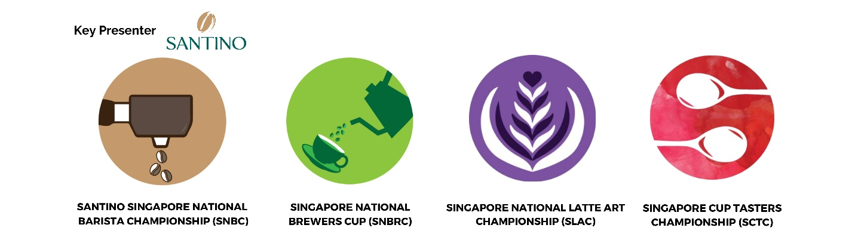

press release
(English translation)

THREE-YEAR COLLABORATION BETWEEN SINGAPORE COFFEE ASSOCIATION AND IEG ASIA - HOSTING THE SINGAPORE NATIONAL COFFEE CHAMPIONSHIPS

Rimini (Italy) 22 February 2024 - Over the next three years, from 2024 to 2026, the Singapore Coffee Association will be staging the Singapore National Coffee Championship (SNCC) alongside IEG Asia Pte Ltd events. In 2024, it will be hosted during Speciality Coffee & Tea Asia which will be co-located with SIGEP Asia and Restaurant Asia, following the acquisition of the Speciality Coffee & Tea Asia series from Montgomery Events Asia. The competitions will be held from 26 – 28 June 2024 at the Sands Expo & Convention Centre, Singapore.
This year, SNCC will present four competitions: Singapore National Barista Championship (SNBC), Singapore National Latte Art Championship (SNLAC), Singapore National Brewers Cup (SBRC), and the Singapore Cup Tasters Competition (SCTC).
The various competitions highlight the different aspects in the world of coffee – from hand-brewed, filtered coffee and intricate coffee artistry, to distinguishing taste differences in specialty coffees and mixology.
Set against the backdrop of Singapore’s vibrant coffee culture, these prestigious competitions bring coffee enthusiasts, professionals, and industry experts to an internationally recognised platform for professionals to compete, learn and network, while showcasing their skills, creativity, and passion for coffee. The national champions would then represent Singapore in the World Coffee Championship 2025.
Victor Mah, President of Singapore Coffee Association said, “We are thrilled to host SNCC alongside the inaugural SIGEP Asia, and we are looking forward to celebrating the mastery of Singapore’s baristas. I hope the Championship will inspire a new wave of creativity, innovation, and passion within our coffee community.”
“This collaboration underscores our dedication to elevating the coffee experience, as well as our event, and this partnership with Singapore Coffee Association exemplifies our commitment to curating an extraordinary experience for all on the show floor. I am positive that coupled with SIGEP Asia, SNCC will be a catalyst for further growth and evolution of the coffee industry,” said Ilaria Cicero, Chief Executive Officer of IEG Asia, Organiser of SIGEP Asia.
For more information, please write to us at connect@iegasia.com.sg | www.sigepasia.com.sg | https://en.sigep.it/

PRESS CONTACT ITALIAN EXHIBITION GROUP | media@iegexpo.it
head of corporate communication & media relations: Elisabetta Vitali|
press office manager: Marco Forcellini | international press office coordinator: Silvia Giorgi

This press release contains forecast elements and estimates that reflect the management’s current opinions (“forward-looking statements”), particularly regarding future management performance, realization of investments, cash flow trends and the evolution of the financial structure. For their very nature, forward-looking statements have a component of risk and uncertainty, as they depend on the occurrence of future events. The effective results may differ (even significantly) from those announced, due to numerous factors, including, only by way of example: food service market and tourist flow trends in Italy, gold and jewellery market trends, green economy market trends; the evolution of raw material prices; general macroeconomic conditions; geopolitical factors and evolutions in the legislative framework. Moreover, the information contained in this release does not claim to be complete, and has not been verified by independent third parties. Forecasts, estimates and objectives contained herein are based on the information available to the Company as at the date of this release.

