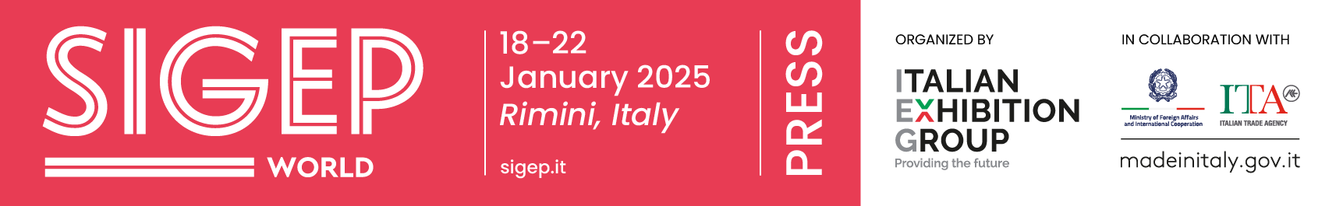

press release
(English translation)

SIGEP WORLD 2025 GOES TO BERLIN
IN THE NAME OF INTERNATIONALITY AND NEW ENTRIES

- Italian Exhibition Group presented stakeholders and foodservice professionals in Germany with the next edition of the event
- A highly international business appointment for the Gelato, Coffee, Pastry&Choco, Bakery and, as of this year, Pizza sectors

Berlin, 14th November 2024 – An international roadshow for an event that is looking increasingly towards the world.
Today, at the Italian Embassy in Berlin, in collaboration with Italian Trade Agency (ITA), Italian Exhibition Group presented the next edition of SIGEP WORLD, The World Expo for Foodservice Excellence, scheduled to take place at Rimini Expo Centre in Italy from 18th to 22nd January 2025. The Berlin event was attended by institutions and stakeholders from the German market: focus was on the opportunities of SIGEP WORLD, a reference point for international foodservice professionals.

“The speakers shared their experiences and insights on how foodservice in Germany is adapting to global changes,” Marco Carniello, IEG’s chief business officer, recounted. “And confirmation was received of how, for the entire out-of-home food universe, SIGEP WORLD is central for staying up-to-date on market developments, anticipating trends and building relationships with key stakeholders of international calibre.”
“In January,” said Flavia Morelli, group exhibition manager of IEG's Food & Beverage division, “we will be adding Pizza, a complementary segment, to the traditional Gelato, Coffee, Pastry & Bakery sectors. A key to strengthening SIGEP WORLD's positioning in the foodservice sector, especially for professionals from outside Europe, where consumption is growing rapidly.”

Jochen Pinsker from Circana: the foodservice situation in Europe
In Berlin, Jochen Pinsker, senior vice president, Industry Advisor Foodservice Europe at Circana, presented market data on the foodservice consumption situation in Europe. Despite a decline in point-of-sale visits, according to September's figures, spending in the sector was up 8% compared to 2019. Confirming the sector’s good health and development potential, Circana's forecasts indicate an average annual growth in consumption of 3.5% for the next two years. The highest growth rates regard pastry, gelato and coffee, the main product categories of SIGEP WORLD’s exhibition offer.

Germany a key player and SIGEP opportunities
During the roadshow, focus was also on the German market with the participation of key players in the German out-of-home sector, including Gerald Schenk, President of the German Pastry Chefs’ Association and Vice-President of the International Union of Bakers and Confectioners (UIBC), Giorgio Ballabeni, co-founder of Ballabeni Icecream, and Markus Elberg, former CEO of Jannys Eis Franchise GmbH.

SIGEP Vision: a look at the future of the out-of-home sector
A core new entry at SIGEP WORLD 2025 will be SIGEP Vision, a global observatory for the out-of-home industry, developed with leading international research institutes: a complete overview of the changes, challenges and opportunities awaiting the sector.
Moreover, with two new halls extending the event layout by a total of 138,000 square metres of exhibition space, the show will be expanding its product offering. The highlights at SIGEP WORLD 25 will include Taste of Tomorrow, a new concept of sustainable gelato parlours based on bio-architecture, the Sustainability District dedicated to the coffee and chocolate supply chains - from the countries of origin right down to the cup - and the Bean-to-Bar Area that will enhance the art and science of chocolate production with a specific space.

Internationality at the centre
SIGEP WORLD is becoming increasingly global. In 2025, 160 countries and 3,000 foreign buyers, hosted through the incoming buyer programme in cooperation with Italian Trade Agency (ITA) and the Ministry of Foreign Affairs, are expected to attend. 1,200 international brands will be exhibiting. Not only high-quality finished products will be on show, but also cutting-edge technologies, innovative ingredients and customised services.

Rimini: a first-class location for hosting the Foodservice community
For 46 years, SIGEP World has been held in Rimini, one of Italy's best-known tourist destinations, able to satisfy the most diverse needs of visitors thanks to the vast availability of hotels, restaurants and international connections. An “experiential” top location for foodservice operators.

SIGEP ITALIAN EXHIBITION GROUP PRESS CONTACTS
head of media relations & corporate communications: Elisabetta Vitali; press office manager: Marco Forcellini, Pier Francesco Bellini; press office specialist: Mirko Malgieri
international press office coordinator: Silvia Giorgi; media@iegexpo.it

MEDIA AGENCY SIGEP: Mind The Pop
Martina Vacca: martina@mindthepop.it, mob. +39 339 748 4994; Fabrizio Raimondi: fabrizio@mindthepop.it, mob. +39 335 389 848; Benedetto Colli: benedetto@mindthepop.it, mob. 380 371 2272; Stefano Chiossi: stefano@mindthepop.it, mob. + 39 388 739 4358.

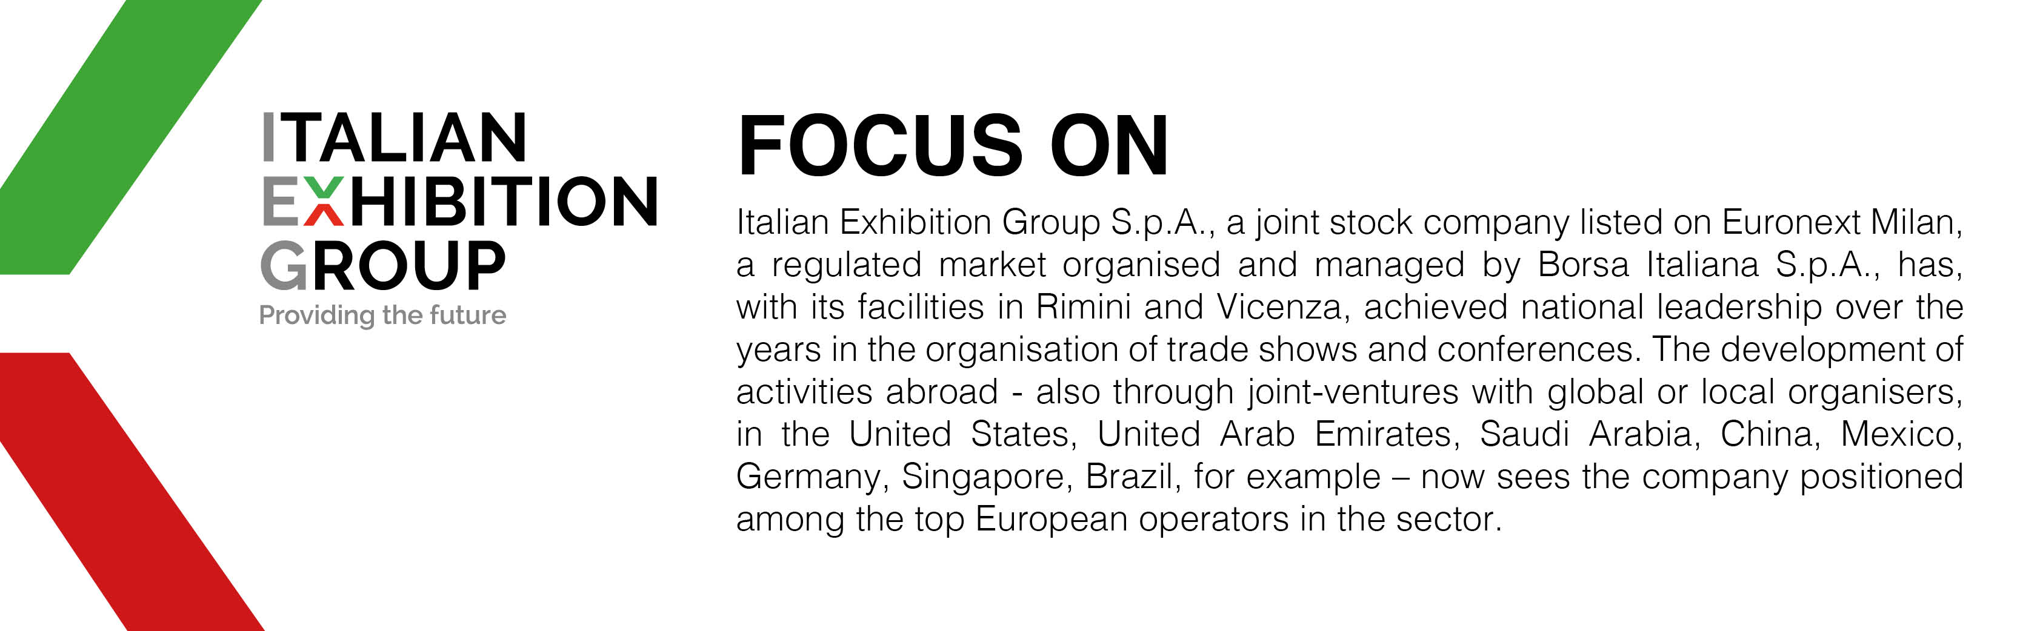

This press release contains forecast elements and estimates that reflect the management´s current opinions (´forward-looking statements´), particularly regarding future management performance, realization of investments, cash flow trends and the evolution of the financial structure. For their very nature, forward-looking statements have a component of risk and uncertainty, as they depend on the occurrence of future events. The effective results may differ (even significantly) from those announced, due to numerous factors, including, only by way of example: food service market and tourist flow trends in Italy, gold and jewellery market trends, green economy market trends; the evolution of raw material prices; general macroeconomic conditions; geopolitical factors and evolutions in the legislative framework. Moreover, the information contained in this release, does not claim to be complete, and has not been verified by independent third parties. Forecasts, estimates and objectives contained herein are based on the information available to the Company as at the date of this release.

