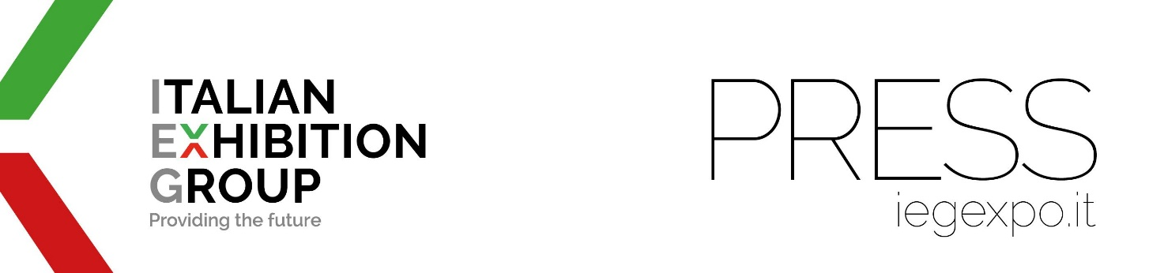

press release
(English translation)

IEG, SIGEP WORLD ANNOUNCES NEW DATES FOR 2026 EDITION

• The event will take place at Rimini Expo Centre (Italy) from Friday 16th to Tuesday 20th January.
• A strategic choice for exhibitors and visitors of the international event dedicated to gelato, pastry, bakery, coffee, and pizza.

Rimini (Italy) 11 March 2025 - Italian Exhibition Group (IEG) announces the new dates for SIGEP WORLD in 2026. The international exhibition for gelato, pastry, bakery, coffee, and pizza will be held at Rimini Expo Centre, Italy, from Friday 16th to Tuesday 20th January. SIGEP WORLD thus confirms its role as the first major event of the year for the foodservice sector, a reference point for trends and innovation.
In fact, in line with the one-month anticipation announced by the Dubai Gulfood for the 2026 edition - dictated by the demands of Ramadan - SIGEP WORLD has also chosen to revise its calendar. This decision has a dual objective: on one hand, to avoid overlaps with other international events, providing exhibitors with a more sustainable management of trade fair appointments; on the other hand, to maximize business opportunities by ensuring an optimal influx of both national and international visitors.
This is therefore a strategic adjustment that confirms IEG's focus, for all its products, on the global dynamics of the sector.

Once again in 2026, in an area traditionally dedicated to innovation and hospitality themes such as Rimini, SIGEP WORLD will offer a complete overview, from products, ingredients and services to equipment, furnishings, packaging solutions and technologies.

Companies will showcase and present the future of the industry to buyers arriving from all over the world, while the major global players in the sectors represented at the event will offer exclusive moments - conferences, championships, demonstrations and so on - that will turn the spotlight on future trends and unexplored tastes.

PRESS CONTACT ITALIAN EXHIBITION GROUP | media@iegexpo.it
head of corporate communication & media relation: Elisabetta Vitali|
press office manager: Marco Forcellini, Pier Francesco Bellini | international press office coordinator: Silvia Giorgi | press office coordinator: Luca Paganin | press office specialist: Nicoletta Evangelisti, Mirko Malgieri

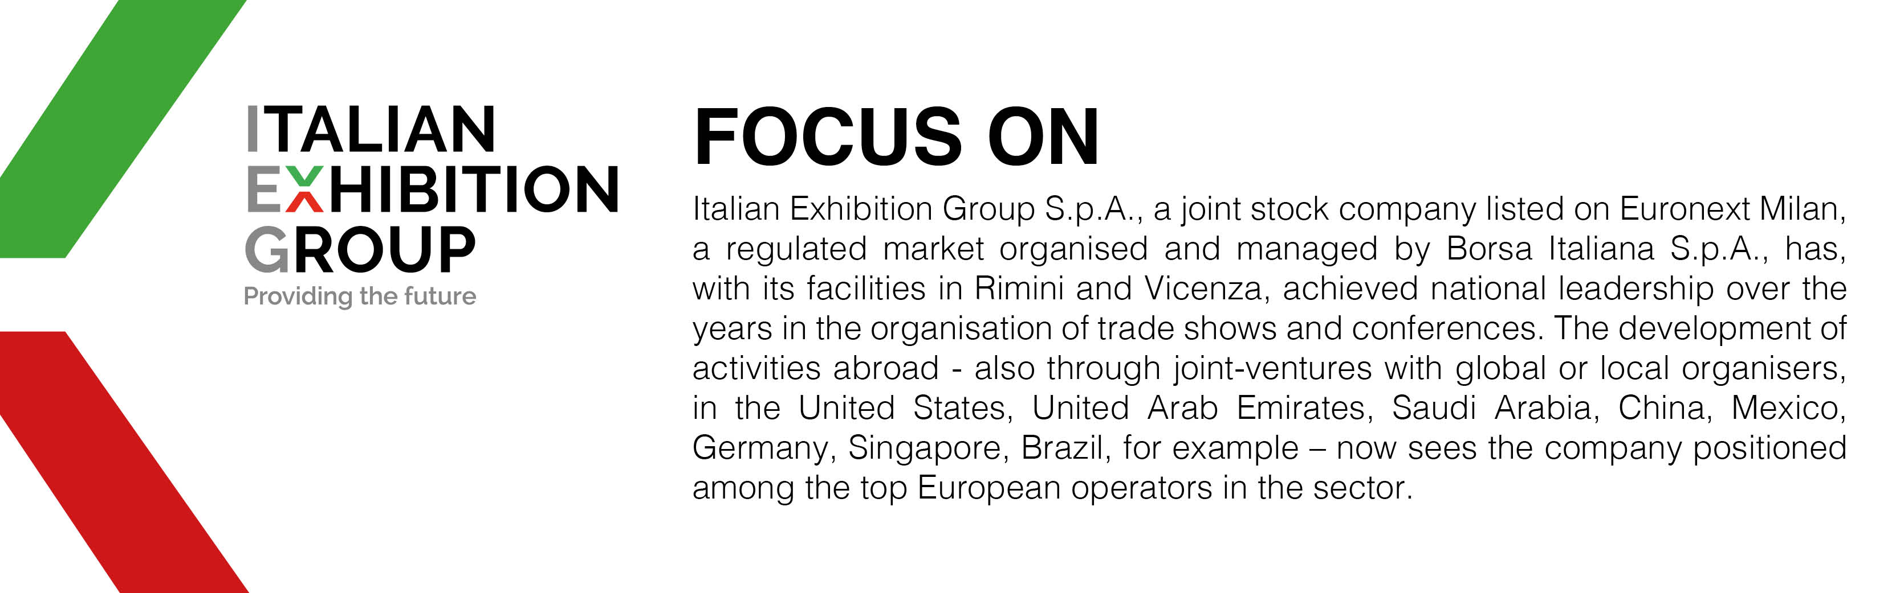

This press release contains forecast elements and estimates that reflect the management´s current opinions (´forward-looking statements´), particularly regarding future management performance, realization of investments, cash flow trends and the evolution of the financial structure. For their very nature, forward-looking statements have a component of risk and uncertainty, as they depend on the occurrence of future events. The effective results may differ (even significantly) from those announced, due to numerous factors, including, only by way of example: food service market and tourist flow trends in Italy, gold and jewellery market trends, green economy market trends; the evolution of raw material prices; general macroeconomic conditions; geopolitical factors and evolutions in the legislative framework. Moreover, the information contained in this release, does not claim to be complete, and has not been verified by independent third parties. Forecasts, estimates and objectives contained herein are based on the information available to the Company as at the date of this release.

