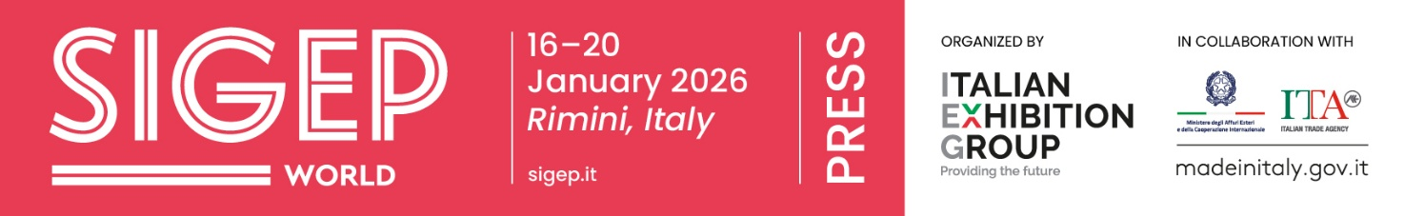

press release
(English translation)
ITALIAN ARTISANAL GELATO CONSOLIDATES ITS EUROPEAN LEADERSHIP: +3% GROWTH OVER THE SUMMER. THE SUPPLY CHAIN ON GLOBAL DISPLAY AT SIGEP WORLD 2026
- SIGEP World, organized by Italian Exhibition Group (IEG), will be back at Rimini Expo Centre from 16th to 20th January 2026, showcasing the widest global offer of artisanal gelato, the Italian frozen desert, together with pastry, coffee, bakery and pizza.

- The sector bids the summer farewell with positive data: for Circana, Italy leads gelato consumption in Europe, representing, with France and Spain, 68% of portions sold in the top 5 markets. And more generally, summer growth in value in Italy was up 3% compared to 2024.

- Internationalization strategies: from Germany to Asia and the “What is Gelato?” campaign as well as the big international competitions where Italy will defend the Gelato World Cup title.
www.sigep.it/en
Rimini (Italy), 2nd October 2025 – Italy leads gelato, the Italian frozen desert, consumption in Europe, representing - together with France and Spain - 68% of portions sold in the top 5 markets. Within a summer growth whose value in Italy stood at +3% compared to 2024, a period in which at least 70% of the sector's estimated 3-billion-euro Italian turnover is concentrated.
These are the positive data with which the entire artisanal gelato supply chain will present itself at SIGEP World - The World Expo for Foodservice Excellence, organized by Italian Exhibition Group (IEG) at Rimini Expo Centre, in Italy, from 16th to 20th January 2026. Now at its 47th edition, the event confirms its role as the international showcase with the very best of industrial gelato, pastry, chocolate, coffee, bread and pizza supply chains. A record-breaking edition is forecast, with 1,300 exhibiting brands from over 30 countries, distributed across 30 halls, and an estimated number of visiting professional operators from over 150 nations.
THE WORLD’S MOST IMPORTANT ARTISANAL GELATO SHOWCASE
The artisanal gelato offer will be the most complete on a worldwide scale, covering the entire value chain. Technology and equipment (from the latest generation machines to refrigerated display cases), raw materials, ingredients and semi-finished products, design and furnishings, and the most innovative digital solutions for every foodservice business model: from independent gelato parlours to organized chains, quick service restaurants, fine dining venues and luxury hospitality.

FOREIGN FOCUS: FROM GERMANY WITH THE SIGEPLAND PROJECT TO INDIA, GUEST COUNTRY 2026
SIGEP World intensifies its initiatives aimed at expanding the presence of Italian artisanal gelato in key markets. Starting with the 'Sigepland' project for Germany, the second world market in terms of number of gelato parlours after Italy. The initiative includes personalized guided tours for thousands of German professionals, also facilitated by the direct Munich-Rimini flight during the days of the Show, to favour networking and encourage them to explore the exhibition offer. A programme brimming with amiable moments designed to offer an immersive experience. SIGEP World’s Guest Country at the 47th edition will be India: a choice that proves the considerable expansion and enormous potential of the Asian market for the Italian hospitality and gelato industry. The delegation of Indian operators arriving at SIGEP will have the chance to closely explore the potential of traditional Italian artisanal gelato. Lastly, the digital “What is Gelato?” campaign, which aims to educate foreign investors and operators on the culture, quality and innovative applications of gelato, the Italian frozen desert, in foodservice. The initiative, in collaboration with Acomag (National Association of Gelato Machinery, Furnishing and Equipment Manufacturers) and Unione Italiana Food – Gelato Product Group, will put the Italian supply chain into contact with major players in global catering through workshops and masterclasses.

BIG COMPETITIONS: ITALY WILL DEFEND THE GELATO WORLD CUP TITLE
The SIGEP World arena will be hosting the highly anticipated Gelato World Cup, the biennial international competition in which teams of gelato professionals will be battling it out. The eleventh edition will see Italy, holder of the 2024 title, competing against 11 other top nations: France, Belgium, Poland, Japan, Singapore, Indonesia, China, Argentina, Mexico, Peru, Ecuador. The teams will take part in eight spectacular tests that combine technical rigour, taste and artistic ability.
SECTOR DATA, SUMMER CONFIRMS GROWTH
Circana's CREST data underline the centrality of Italy in the EU market: «Despite a few uncertainties linked to unfavourable climatic conditions, summer is a gelato consumption driver in Italy, France and Spain, which together represent 68% of portions served in the top 5 European countries,» explained Matteo Figura, executive director of Foodservice Italia at Circana. «Gelato confirms its status within the small accessible luxury category that consumers are not willing to relinquish.»
While according to AIG (Italian Gelato Makers’ Association), the summer confirmed consumption forecasts. In value terms, growth stood at +3% compared to 2024: driving the sector was above all central Italy (+5%) thanks to cities of art, and the south (+4%), while the north showed minimal growth, mainly due to bad weather.
PRESS CONTACT ITALIAN EXHIBITION GROUP | media@iegexpo.it
head of corporate communication & media relation: Elisabetta Vitali|
press office manager: Marco Forcellini, Pier Francesco Bellini | international press office coordinator: Silvia Giorgi | press office coordinator: Luca Paganin | press office specialist: Nicoletta Evangelisti, Mirko Malgieri

MEDIA AGENCY SIGEP World: Mind The Pop
Martina Vacca: martina@mindthepop.it, mob. +39 339 748 4994; Fabrizio Raimondi: fabrizio@mindthepop.it, mob. +39 335 389 848; Benedetto Colli: benedetto@mindthepop.it, mob. 380 371 2272; Stefano Chiossi: stefano@mindthepop.it, mob. + 39 388 739 4358.

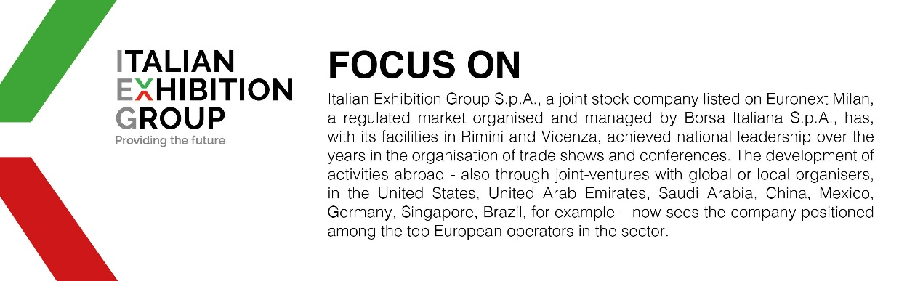

This press release contains forecast elements and estimates that reflect the management´s current opinions (´forward-looking statements´), particularly regarding future management performance, realization of investments, cash flow trends and the evolution of the financial structure. For their very nature, forward-looking statements have a component of risk and uncertainty, as they depend on the occurrence of future events. The effective results may differ (even significantly) from those announced, due to numerous factors, including, only by way of example: food service market and tourist flow trends in Italy, gold and jewellery market trends, green economy market trends; the evolution of raw material prices; general macroeconomic conditions; geopolitical factors and evolutions in the legislative framework. Moreover, the information contained in this release, does not claim to be complete, and has not been verified by independent third parties. Forecasts, estimates and objectives contained herein are based on the information available to the Company as at the date of this release.

