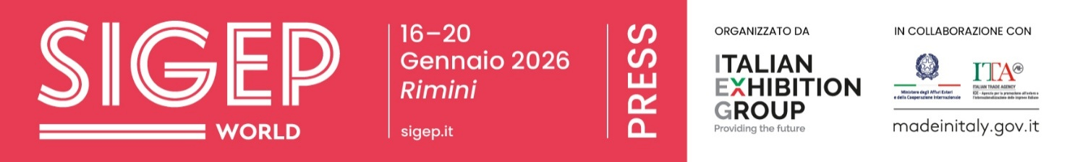

press release no. 3
IEG, THE INTERNATIONAL TRENDS THAT WILL ENVIGORATE SIGEP WORLD 2026
• The Madrid roadshow marks a key milestone on the road to Italian Exhibition Group’s big event to be held at Rimini Expo Centre from 16th to 20th January 2026
• Spain is Europe’s most dynamic out-of-home market with a +2.4% growth in the first nine months of 2025, ahead of the five main European markets’ average of +1.8%. The roadshow has also opened up new business opportunities between Italian companies and Iberian groups
• In Rimini, gelato will consolidate its position as a global gastronomic language, while focus is growing on new-generation bars and the entire pizza supply chain is getting organized
• India confirmed as Guest Country 2026, reflecting the interest of expanding markets in contemporary food service formats and models
sigep.it
Rimini, 10 November 2025 — Madrid is the starting point for the international journey towards SIGEP World 2026, Italian Exhibition Group’s big event for the gelato, pastry, chocolate, coffee, bakery and pizza sectors. The roadshow in the Spanish capital, hosted by the Italian Embassy and organized in collaboration with the Italian Trade Agency and the Italian Chamber of Commerce for Spain, saw analysts, associations and key players in the Iberian foodservice sector gather for a round table discussion on the transformations taking place in urban consumption, service styles and business models.

MADRID OPENS NEW MARKET AGENDAS
A comparative analysis has shown that Spain is currently one of the most dynamic markets in Europe for out-of-home consumption. Circana data presented during the roadshow demonstrate that, among the main European countries (France, the United Kingdom, Spain, Italy and Germany), overall growth in the first nine months of 2025 was +1.8% compared to the previous year. Spain recorded an increase of +2.4% and is the country with the highest growth in both spending at foodservice establishments and the number of visits.
In this context, gelato parlours and pastry shops are still central elements in contemporary urban concepts as identifying components of the gastronomic experience, able to combine artisan quality and replicable models. The journey will proceed to Rimini, where direct working agendas between Italian companies and Spanish groups have already been planned. The exhibition destination will also be more easily accessible due to direct flights not only from Munich but also from Madrid, thus favouring the participation of buyers, chains and international operators.
INDIA GUEST COUNTRY 2026
Another strategic focus is India, which will be attending SIGEP World as guest country with a delegation of buyers, media representatives and institutions: a rapidly developing market interested in advanced food service and hospitality models.

GELATO AS A SPECIALITY SKILL INTEGRATED INTO THE FOOD SERVICE INDUSTRY
One of the central themes of SIGEP World 2026 will be gelato, the Italian frozen dessert, as a professional speciality to be integrated into the menus of restaurant chains, hotels and cafés. Thanks to Gelato Meets Chains and the international “What is Gelato?” campaign, gelato is being promoted as a speciality skill and business opportunity: restaurant chains, hotel groups and coffee shops will therefore have the tools to integrate the Italian frozen dessert permanently into their menus, transforming it into a distinctive element of their offer.

NEW SCENARIOS FOR HOTELS AND COFFEE SHOPS: TWO OBSERVATORIES ON THE CHANGING MARKET
The Luxury Hotel Food Experience will highlight emerging trends in high-end hotels through authoritative contributions and strategic visions from the academic world, food & beverage managers of large chains and pastry chefs. An operational discussion on service aesthetics, gastronomic identity and new forms of experience in premium contexts.
The Innovation Bar, on the other hand, will address the more concrete aspect of the market: how bars are changing. Intelligent robotics, optimized workflows, coffee specialities as a language rather than a fad, without forgetting new ways of consuming the beverage.

PIZZA (R)EVOLUTION: THE ENTIRE SUPPLY CHAIN TAKES THE STAGE AT THE EXPO
The pizza project is growing with the entire supply chain getting organized: toppings, dough, technologies, service models. The Pizza Arena, together with Vision Plaza, will provide a lively observatory on trends and methods with exceptional partners, including 50 Top Pizzas and international training organisations.

PRESS CONTACT ITALIAN EXHIBITION GROUP | media@iegexpo.it
head of corporate communication & media relation: Elisabetta Vitali|
press office manager: Marco Forcellini, Pier Francesco Bellini | international press office coordinator: Silvia Giorgi | press office coordinator: Luca Paganin | press office specialist: Nicoletta Evangelisti, Mirko Malgieri
MEDIA AGENCY SIGEP World: Mind The Pop
Martina Vacca: martina@mindthepop.it, mob. +39 339 748 5994; Fabrizio Raimondi: fabrizio@mindthepop.it, mob. +39 335 389 848; Benedetto Colli: benedetto@mindthepop.it, mob. 380 371 2272; Stefano Chiossi: stefano@mindthepop.it, mob. + 39 388 739 4358.

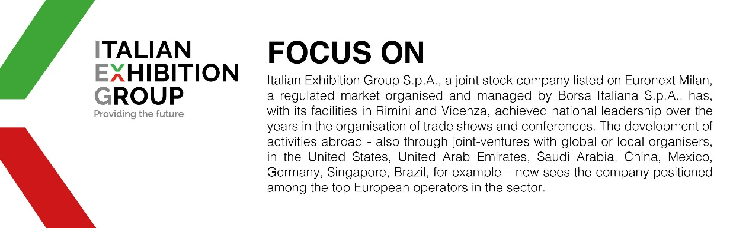

This press release contains forecast elements and estimates that reflect the management´s current opinions (´forward-looking statements´), particularly regarding future management performance, realization of investments, cash flow trends and the evolution of the financial structure. For their very nature, forward-looking statements have a component of risk and uncertainty, as they depend on the occurrence of future events. The effective results may differ (even significantly) from those announced, due to numerous factors, including, only by way of example: food service market and tourist flow trends in Italy, gold and jewellery market trends, green economy market trends; the evolution of raw material prices; general macroeconomic conditions; geopolitical factors and evolutions in the legislative framework. Moreover, the information contained in this release, does not claim to be complete, and has not been verified by independent third parties. Forecasts, estimates and objectives contained herein are based on the information available to the Company as at the date of this release.

