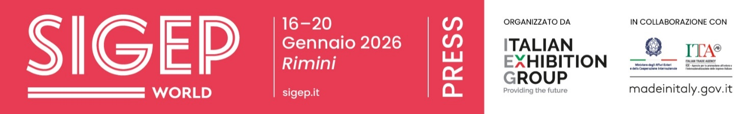

press release no. 4
IEG, SIGEP 2026: 1,300 BRANDS, NEW COUNTRIES AND PROJECTS FOR CHAINS AND THE HOTEL INDUSTRY.
THREE FOODSERVICE INNOVATION HUBS IN ARRIVAL

- From 16th to 20th January, SIGEP World will be back at Rimini Expo Centre with 1,300 brands and a +28% increase in foreign exhibitors from 45 countries. Newcomers from Canada to Singapore will be making their debut, together with collective groups from Saudi Arabia, China, Ukraine and Brazil. As Guest Country, India will be in attendance with a delegation of 50 buyers and institutional representatives

- The buyer programme will bring 500 top buyers from 75 countries to Rimini, including chains, importers and distributors

- Three new hubs will be featured: Kitchen Equipment Hub, Frozen Product Hub and Digital District

sigep.it
Rimini, 15 December 2025 — SIGEP World – The World Expo for Foodservice Excellence, the International Gelato, Pastry, Chocolate, Bakery, Pizza and Coffee Show, organised by Italian Exhibition Group (IEG), will be back at Rimini Expo Centre from Friday 16th to Tuesday 20th January. An event that not only showcases products and technologies, but also gathers manufacturing excellence, innovation and international markets under one roof.

THE OFFER IS GROWING, THE MAP OF ATTENDING COUNTRIES IS WIDENING
SIGEP World 2026 will be back with a larger than ever exhibition area featuring 1,300 exhibiting brands bringing the best of Made in Italy to Rimini, from traditional supply chains to the most advanced technologies. Alongside a solid and outstanding Italian attendance, represented by leading companies in the foodservice supply chain, the foreign component will also be significantly bigger, up 28% with 45 countries ready to tap into the global dolce foodservice and out-of-home market.

In this constantly expanding geography, a group of countries stands out which, in terms of industrial weight and capacity for innovation, together with Italy, is driving the sector’s main supply chains. Germany, Spain, France, China, Turkey, Belgium, Poland, the United States, Greece and Denmark will be attending the show with technologies, ingredients, products and know-how able to influence trends and strategies in the global market.
New entries for the 2026 edition will be joining this scenario: Canada, Saudi Arabia, Algeria, Ecuador, Estonia, Serbia, Singapore, Nepal and the Czech Republic. The show will also feature the National Hall, the official collectives of countries that choose SIGEP World as a strategic showcase for their top products: Saudi Arabia, China, Ukraine and Brazil will be attending this year.
The international picture will be completed by India, Guest Country 2026, which is expected to send a delegation of 50 top buyers and institutional representatives, as well as exhibitors specialising in gelato technologies.

THE BUYER PROGRAMME BOOSTS SIGEP WORLD’S INTERNATIONAL IMPORTANCE
The larger offer will be accompanied by intense incoming activity: the Top Buyer Programme will bring 500 buyers from 75 countries to Rimini with the United States, India, Canada and Brazil leading the way in terms of representation. The profiles involved will include major foodservice chains, large importers and distributors committed to selecting technologies, products and solutions to anticipate the needs of global markets.

COMPLETE SUPPLY CHAIN AND TRANSVERSAL SECTORS ON THE MOVE
At SIGEP World, supply chains interact with each other and depict a rapidly changing foodservice industry.
Gelato will still be the main player with a real cultural project – featuring the What is Gelato? and Gelato Meets Chains initiatives – designed to show chains, hotels and international operators how, and with what business model, Italian gelato is now a global business lever.
The pastry sector will be bigger, driven by frozen products and technologies that give patisseries many more possibilities; chocolate will bring the big players into the field with increasingly sustainable processes; the bakery sector will express a new industrial maturity, while pizza will be stepping on the accelerator with Pizza (R)evolution and advanced doughs and formats that are conquering the international market.
Coffee will complete the picture with an itinerary that goes from its origins to the cup, passing through the Sustainability District, where producing countries and projects specifically for sustainable supply chains, from African cooperation to Latin American cocoa, will be grouped. Last but not least, the Innovation Bar, where AI and robotics will reinterpret the contemporary coffee shop.
Added to this trajectory, the Luxury Hotel Food Experience, a new strategic element that will connect high-end hotel brands with the excellence of the event's supply chains, creating experiential tables and opportunities for discussion for Food & Beverage managers and chefs from top hotels.
Everything that connects and enhances traditional supply chains will also be developed: foodservice technologies will feature in the Kitchen Equipment Hub, a showcase for solutions that will change the way food is produced, served and managed; the Frozen Product Hub will snapshot the growth of quality frozen foods, becoming a strategic ally for formats and chains, while digital services will find a home in the new Digital District, where software, smart payments and robotics will redesign work in both the dining room and the kitchen.

PRESS CONTACT ITALIAN EXHIBITION GROUP | media@iegexpo.it
head of corporate communication & media relation: Elisabetta Vitali|
press office manager: Marco Forcellini, Pier Francesco Bellini | international press office coordinator: Silvia Giorgi | press office coordinator: Luca Paganin | press office specialist: Nicoletta Evangelisti, Mirko Malgieri
MEDIA AGENCY SIGEP World: Mind The Pop
Martina Vacca: martina@mindthepop.it, mob. +39 339 748 5994; Fabrizio Raimondi: fabrizio@mindthepop.it, mob. +39 335 389 848; Benedetto Colli: benedetto@mindthepop.it, mob. 380 371 2272; Stefano Chiossi: stefano@mindthepop.it, mob. + 39 388 739 4358.

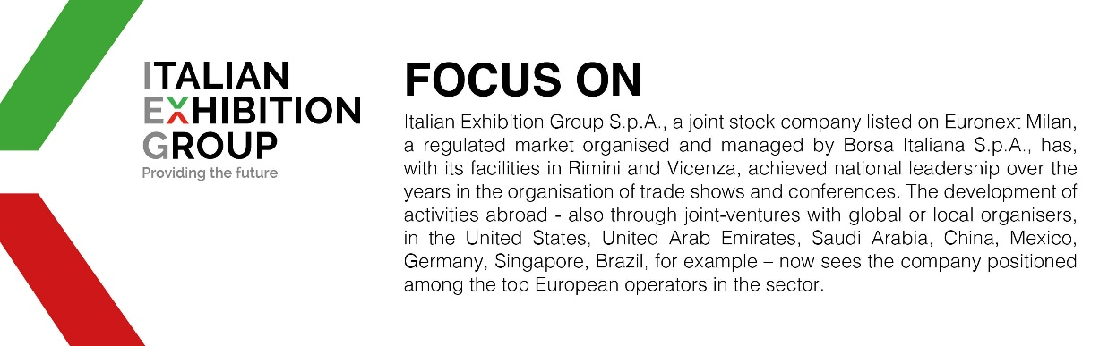
This press release contains forecast elements and estimates that reflect the management´s current opinions (´forward-looking statements´), particularly regarding future management performance, realization of investments, cash flow trends and the evolution of the financial structure. For their very nature, forward-looking statements have a component of risk and uncertainty, as they depend on the occurrence of future events. The effective results may differ (even significantly) from those announced, due to numerous factors, including, only by way of example: food service market and tourist flow trends in Italy, gold and jewellery market trends, green economy market trends; the evolution of raw material prices; general macroeconomic conditions; geopolitical factors and evolutions in the legislative framework. Moreover, the information contained in this release, does not claim to be complete, and has not been verified by independent third parties. Forecasts, estimates and objectives contained herein are based on the information available to the Company as at the date of this release.

