press release
(English translation)

SIGEP WORLD CHRISTMAS OBSERVATORY BY IEG:
NEW IDEAS AND TRENDS FOR “THE FESTIVE TABLE”

- Comments from top Italian and European pastry chefs
- And in France, from seaweed and yuzu comes the “panettone for aperitif”
- Pastry purchases are worth 11.4 billion euros with consumption up by 1.5%; but climate change is affecting costs

Rimini(Italy), 26th November 2024 – Classic or chocolate, with filling and suitable for any occasion, once again nobody will be doing without their panettone this Christmas. Even though the classic “rivalry” with pandoro, Italy’s other Christmas cake par excellence, is experiencing a successful comeback.
Global pastry consumption and trends in view of Christmas have again come under the watchful eye of the Observatory of Sigep, the International Gelato, Pastry, Bakery, Coffee - and, as of this year, also Pizza - Show, organised by IEG - Italian Exhibition Group (Rimini Expo Centre, 18-22 January 2025, sigep.it).

THE FIGURES
A snapshot of the Sigep Christmas 2024 Observatory by IEG reveals positive European data: +1.5% compared to 2023 for pastry consumption, while purchases stand at 11.4 billion euros (Source: CREST, Circana). “In order to counteract the high cost of living, consumers are introducing different strategies between northern and southern Europe: while in Italy and Spain they sometimes renounce a few menu items, such as dessert, in the rest of Europe, focus is on the experiential occasions of the Pastry Shop, the highest expression of hedonism in out-of-home consumption. Nevertheless, pastry consumption in Italy accounts for 40.6% of the category’s total consumption at European level,” says Matteo Figura, Out of Home Market Expert and Foodservice Area Director for Circana Italia.

THE ISSUE OF RISING RAW MATERIAL PRICES
As Sigep Observatory by IEG 2024 interviews with Europe's top pastry chefs revealed, the sector is facing high raw material prices: climate change has reduced the production of hazelnuts with a consequent +40% increase in costs that inevitably also falls on the end consumer; a jump that reaches +50% in the case of chocolate.

TRENDS AND NEW IDEAS: COMMENTS FROM TOP ITALIAN AND EUROPEAN PASTRY CHEFS
According to Giuseppe Piffaretti, Swiss master pastry chef in the Ticino and creator of the World Panettone Cup: “Traditional panettone is an important segment of pastry shop economy in the Ticino, which has some 30 artisan producers. In the border regions between Switzerland and Italy, reinterpretations, such as our cake with blueberries, apricots, sultanas, grappa and chestnuts, are much appreciated. During Christmas, the classic panettone in its chocolate version is highly popular”.

For Luigi Biasetto, master pastry chef from Veneto and AMPI lecturer (Academy of Italian Master Pastry Chefs): “Traditional Milanese panettone is already the most popular with our customers, but the big surprise is pandoro, which is experiencing a comeback after years in which it suffered from big industry’s market strategies: we foresee a 22% increase in sales. New for 2024 is the Christmas Crown, similar to the Christmas wreath and decorated with mulled seasonal fruit and spices”.

Marta Boccanera, master pastry chef in Rome and vice-president of APEI (Ambasciatori Pasticceri dell'Eccellenza Italiana, Italian Pastry Ambassadors of Excellence): “We have forecast an increase in panettone sales of around 10-15% and doubled volumes for pandoro, but pastry chefs are having to deal with the rising price of raw materials. Boccanera has also envisaged a cake that is also ideal for holiday breakfast, reminiscent of ‘pangiallo’ with dried fruit, citron and candied orange.”

“Classic panettone represents 40% of our sales,’ says Rimini-born Roberto Rinaldini, member of Relais Dessert International and president of the Junior Pastry World Championship at Sigep, “But our gourmet proposal is also growing with high-end proposals such as the Dante panettone enriched with pistachios, wild strawberries and cherries, ideal for festive lunches and personal or corporate gifts”.

Christophe Louie, Parisian baker-patissier, tells the Sigep Observatory about two big novelties: “We are aiming at coffee, spice and pear panettone made in collaboration with Maison Verlet, and panettone with seaweed and yuzu with Maison Petrossian as an aperitif.”

For José Romero, Spanish pastry chef and EPGB lecturer from Barcelona: “In Spain, panettone sales have tripled in the last ten years, although without reaching Italian levels. The classic version of panettone is very popular, and we offer chocolate and pistachio as variants'. The Spanish Christmas cake par excellence? ‘Undoubtedly the “Turrón de yema”, with sugar, almonds and citrus fruits, is burnt in the top layer giving the effect of Catalan cream”.

PRESS CONTACT SIGEP ITALIAN EXHIBITION GROUP
head of media relation & corporate communication: Elisabetta Vitali; press office manager: Marco Forcellini, Pier Francesco Bellini; international press office coordinator: Silvia Giorgi; press office coordinator: Luca Paganin; press office specialist: Mirko Malgieri - media@iegexpo.it

MEDIA AGENCY SIGEP: Mind The Pop
Martina Vacca: martina@mindthepop.it, mob. +39 339 748 5994; Fabrizio Raimondi: fabrizio@mindthepop.it, mob. +39 335 389 848; Benedetto Colli: benedetto@mindthepop.it, mob. 380 371 2272; Stefano Chiossi: stefano@mindthepop.it, mob. + 39 388 739 4358.

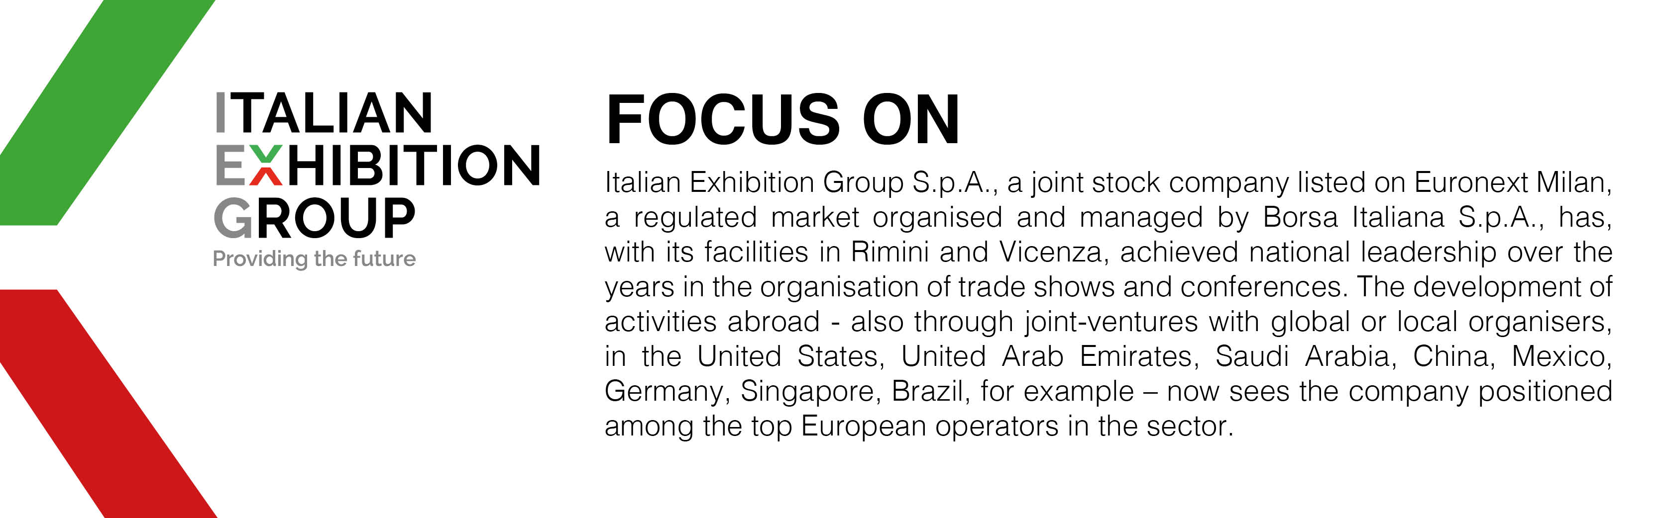

This press release contains forecast elements and estimates that reflect the management´s current opinions (´forward-looking statements´), particularly regarding future management performance, realization of investments, cash flow trends and the evolution of the financial structure. For their very nature, forward-looking statements have a component of risk and uncertainty, as they depend on the occurrence of future events. The effective results may differ (even significantly) from those announced, due to numerous factors, including, only by way of example: food service market and tourist flow trends in Italy, gold and jewellery market trends, green economy market trends; the evolution of raw material prices; general macroeconomic conditions; geopolitical factors and evolutions in the legislative framework. Moreover, the information contained in this release, does not claim to be complete, and has not been verified by independent third parties. Forecasts, estimates and objectives contained herein are based on the information available to the Company as at the date of this release.

