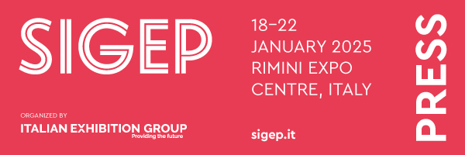

press release
(English translation)

SIGEP OBSERVATORY SUMMER 2024: GELATO, DATA AND TRENDS

- Consumption in Europe: between +3 and +5% in Spain; up to +12% in Italy in the art cities
- New flavours? White chocolate and asparagus in Germany
- From Italy, gelato in homage to Sinner: carrot, tangerine, lemon

Italy, Rimini, 2nd May 2024 – On the brink of summer, Sigep Observatory (46th International Artisan Dolce World Expo, organised in Italy by IEG - Italian Exhibition Group, at Rimini Expo Centre from 18th to 22nd January 2025 www.sigep.it) takes a snapshot of data and trends in the European gelato industry.

THE EUROPEAN AND ITALIAN SCENARIO. FORECASTS FOR SUMMER 2024
Marco Carniello (pictured), CBO of IEG, explains: “In Italy, Spain, France, Germany and the UK, 2.2 billion gelatos were sold in 2023, a year in which, according to CREST-Circana data, gelato consumption in Europe grew by 4.7%. Circana forecasts an increase in 2024 thanks to consumers who see gelato as an accessible pleasure in a still uncertain economic context.”
Flavia Morelli (pictured), head of IEG's food & beverage shows, adds: “In Italy in particular, according to economic categories, such as the Italian Association of Gelato Makers, the positive sales performances recorded this spring imply an estimated increase in consumption in Italy up from 6% to 12% in art cities due to the high number of international tourists.”

SUMMER TRENDS: A THOUSAND FLAVOURS UNDER THE SUN
For Summer 2024, Italian master gelato maker, Giancarlo Timballo, President of the Gelato World Cup, will be creating new flavours drawing on local traditions and working with local products. His proposals include raspberry and rosemary gelato.
Eugenio Morrone, a master gelato maker with two famous gelato parlours in Rome, has created a carrot, tangerine and lemon gelato in homage to the great Jannik Sinner. The “surprise”, however, is the return of the tiramisu flavour, increasingly in demand, especially among foreign tourists.
Marco Miquel Sirvent, president of the Asociación Nacional Heladeros Artesanos de España, highlights the health aspect with a trend for purchasing low-sugar gelato (although nougat, vanilla and chocolate continue to endure). Forecasts for summer 2024 are optimistic with a 3-5% increase in consumption.
German consumers are poised between great classics and curiosity for new ideas, as explained by Dario Fontanella, founder of a well-known gelato parlour in Mannheim, Germany, which, for summer 2024, is offering white chocolate gelato with asparagus, typical of the Baden-Württemberg region. New flavours include bergamot with curry and wasabi.

PRESS CONTACT SIGEP ITALIAN EXHIBITION GROUP
head of media relation & corporate communication: Elisabetta Vitali; press office manager: Marco Forcellini; Pier Francesco Bellini; press office specialist: Mirko Malgieri
international press office coordinator: Silvia Giorgi; media@iegexpo.it

MEDIA AGENCY SIGEP: Mind The Pop
Martina Vacca: martina@mindthepop.it, mob. +39 339 748 4994; Fabrizio Raimondi: fabrizio@mindthepop.it, mob. +39 335 389 848; Benedetto Colli: benedetto@mindthepop.it, mob. 380 371 2272; Stefano Chiossi: stefano@mindthepop.it, mob. + 39 388 739 4358.

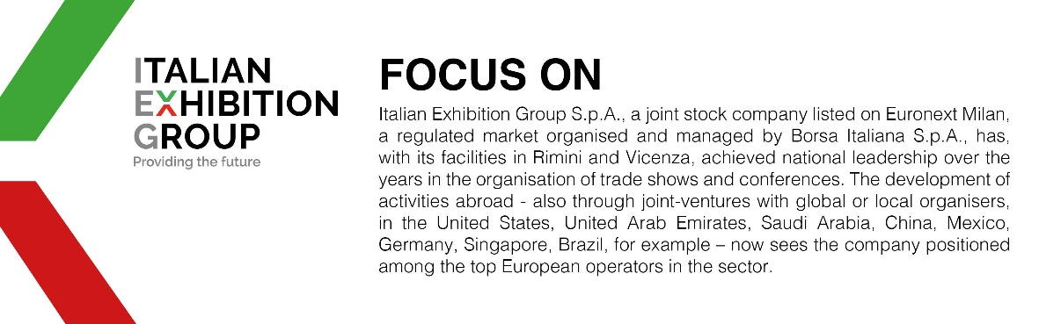

This press release contains forecast elements and estimates that reflect the management’s current opinions (“forward-looking statements”), particularly regarding future management performance, realization of investments, cash flow trends and the evolution of the financial structure. For their very nature, forward-looking statements have a component of risk and uncertainty, as they depend on the occurrence of future events. The effective results may differ (even significantly) from those announced, due to numerous factors, including, only by way of example: food service market and tourist flow trends in Italy, gold and jewellery market trends, green economy market trends; the evolution of raw material prices; general macroeconomic conditions; geopolitical factors and evolutions in the legislative framework. Moreover, the information contained in this release does not claim to be complete, and has not been verified by independent third parties. Forecasts, estimates and objectives contained herein are based on the information available to the Company as at the date of this release.

