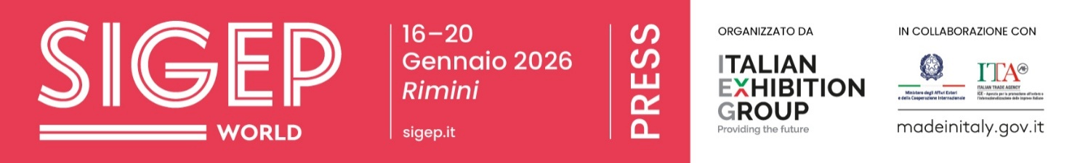

press release
(English translation)

SIGEP OBSERVATORY SUMMER 2025:
EXPECTED +4% INCREASE IN GELATO SALES IN ITALY

- In Italy, artisan gelato sector revenues in 2024 were close to 3 billion euros
- Italy is the European benchmark with more than 600 million servings sold in 2024 (26.4%), ahead of Germany (25.1%) and Spain (20.6%)
- From “inverted” stracciatella to beetroot: the flavors and ingredients for summer 2025

Rimini (Italy), 22 May 2025 - A 4% growth in artisan gelato sales in Italy during the summer season.
This is what emerges from the Observatory of SIGEP World (the World Expo for Foodservice Excellence, organized by IEG - Italian Exhibition Group and scheduled to take place at Rimini Expo Center, Italy, from 16-20 January, 2026), which has been recording data and trends in the gelato sector prior to the summer season for twenty-five years.

THE DATA: THE EUROPEAN AND ITALIAN SCENE. FORECASTS FOR SUMMER 2025
According to SIGEP World’s Observatory, based on data from CREST-Circana and the Italian Gelato Makers' Association, the summer months of 2025 will be under the banner of recovery, especially for Italy.
In Europe in 2024, despite a slight drop in visits (-0.5%), the craving for gelato never ceased, registering a +2.1% increase. Italy sold more than 600 million servings, ranking first with 26.4% ahead of Germany (25.1%) and Spain (20.6%) in the 5 target markets, complemented by France and Great Britain. «The propensity to consume is growing,” reiterates Matteo Figura, executive director Foodservice Italy at Circana, ”In 4 out of 100 visits, consumers include gelato among their out-of-home choices. Even at a time of uncertainty, Europeans are not giving up this experience, offering opportunities and growth incentives for the entire supply chain.»
Trends also confirmed by Claudio Pica, secretary general of the Italian Gelato Makers’ Association (AIG): «For summer 2025, we foresee a growth in sales of around 4% throughout Italy. But artisans need to invest more in training, not only on creations in the workshop: unfortunately, staff shortage is also an issue for gelato parlors, which are short of about 15-20 thousand counter workers.»
In 2024, the artisan gelato sector in Italy (Sources: UIF, ACOMAG, Confartigianato, Confesercenti, FIPE-Confcommercio, Demoskopika, ISTAT, TCI, ARPA) grew by 0.5 to 1%, reaching almost 3 billion euros in revenues (2.9 billion in 2023).
FROM INVERTED STRACCIATELLA TO MONTEPULCIANO GELATO: THE NEW FLAVORS FOR SUMMER
Trends for summer 2025? Here is what the great masters and emerging professionals from North to South have to say. Antonio Mezzalira, Three Cones for Gambero Rosso with his ‘Golosi di Natura’ gelato parlor in Piazzola sul Brenta (Padua) and author of recipes for the gelato world, predicts: «New products we are focusing on include flavors such as aronia, a berry rich in antioxidants with a taste similar to blueberry, and beetroot, which does not raise the glycemic index. Prices have risen in the territory mainly due to a series of increases, but are still more contained than elsewhere. However, consumers have not shown concern, recognizing the value of artisan gelato. I would mention a trend that I have long been hoping for, which is price differentiation by flavor, as is the case of pizza. At my parlor, for example, prosecco gelato costs 3 euros per cup instead of €2.50.»
Taila Semerano, who was crowned Best Emerging Gelato Maker 2024 at SIGEP World in Rimini and who, after graduating from Bocconi University, went back to the Da Ciccio gelato parlor founded by her grandfather in Ostuni (Brindisi), explains, «We are returning to classic flavors with simple ingredients processed in an artisanal way. New entries this year include inverted stracciatella with a dark chocolate base and white chocolate chips. Moreover, the gelato parlor is moving ever closer to pastry and so interest in flavors that include cookies and crunchies is also growing.»
According to Sergio Colalucci, president of the Gelato World Cup and owner of the homonymous gelato parlor in Nettuno (Rome), it is important «to have an offer with no added sugars, 100% vegetable and free of milk, lactose and derivatives. I would like to highlight two of the most popular flavors currently in my parlor: a chocolate fondant enriched with a Montepulciano d'Abruzzo sauce, macerated in sour cherries; the other is a gourmet cream, delicately scented with vanilla and enriched with lemon zest and Colonia Veneta almonds.»
Rimini-born Marco Ottaviani, owner of ‘Il Castello’, initially a computer scientist and a great lover of art in all its forms, highlights the new trends for summer 2025: «Complex aroma profiles and balanced sweetness are in demand, such as our ‘Vento d'Oro,’ a flavor that combines saffron, pistachio and Sichuan pepper. And the enhancement of local ingredients, such as our Lavender, Milk and High Mountain Honey flavor, low in sugar that suggest lightness.»
Moving abroad, Mario Masiá, president of the National Association of Spanish Gelato Makers (ANHCEA), offers a perspective from Spain: «2025 will be a key year for the industry, marked by innovation, sustainability and attention to new consumer tastes. The trend toward international flavors is getting stronger with the introduction of exotic flavors such as matcha, yuzu and Asian mango, while technology is helping to improve texture and to experience customization, partly thanks to digital tools.»

PRESS CONTACT ITALIAN EXHIBITION GROUP | media@iegexpo.it
head of corporate communication & media relation: Elisabetta Vitali|
press office manager: Marco Forcellini, Pier Francesco Bellini | international press office coordinator: Silvia Giorgi | press office coordinator: Luca Paganin | press office specialist: Nicoletta Evangelisti, Mirko Malgieri

MEDIA AGENCY SIGEP World: Mind The Pop
Martina Vacca: martina@mindthepop.it, mob. +39 339 748 4994; Fabrizio Raimondi: fabrizio@mindthepop.it, mob. +39 335 389 848; Benedetto Colli: benedetto@mindthepop.it, mob. 380 371 2272; Stefano Chiossi: stefano@mindthepop.it, mob. + 39 388 739 4358.

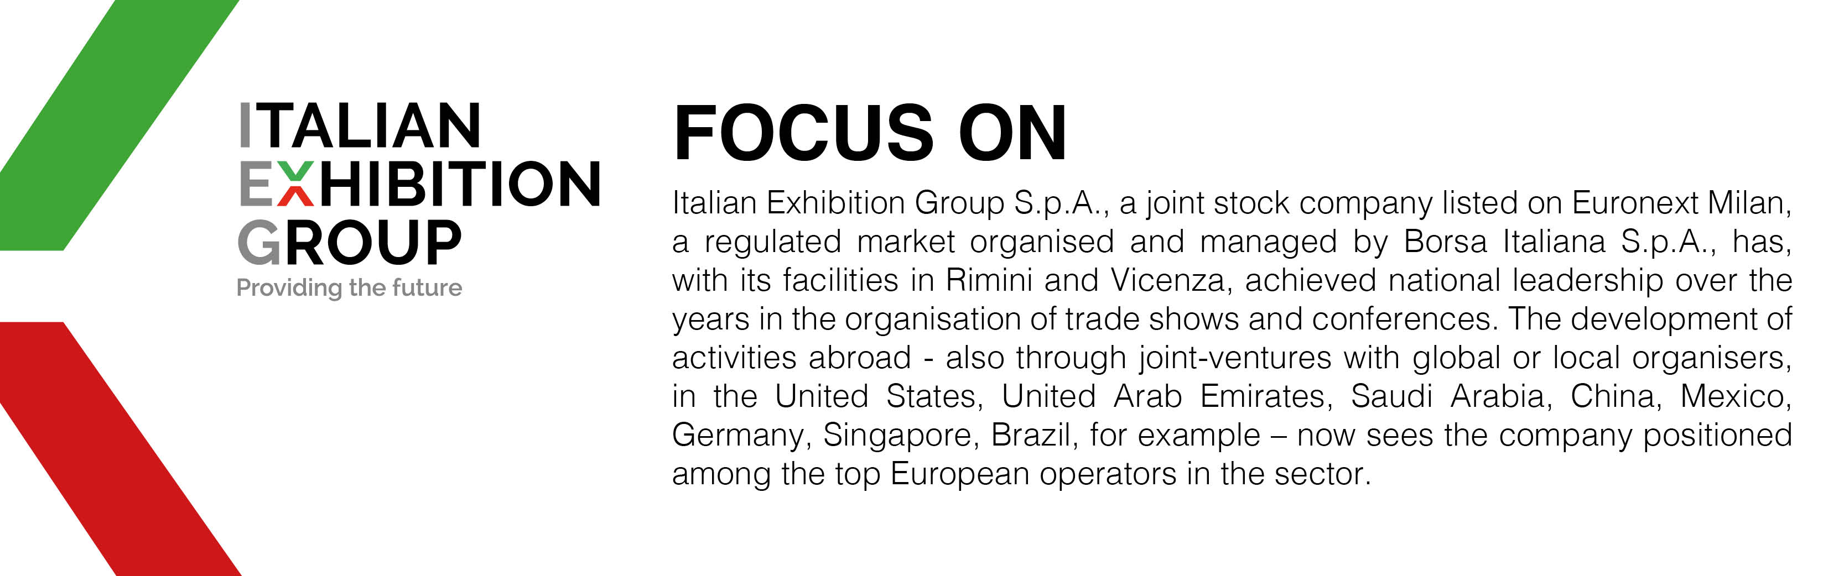

This press release contains forecast elements and estimates that reflect the management´s current opinions (´forward-looking statements´), particularly regarding future management performance, realization of investments, cash flow trends and the evolution of the financial structure. For their very nature, forward-looking statements have a component of risk and uncertainty, as they depend on the occurrence of future events. The effective results may differ (even significantly) from those announced, due to numerous factors, including, only by way of example: food service market and tourist flow trends in Italy, gold and jewellery market trends, green economy market trends; the evolution of raw material prices; general macroeconomic conditions; geopolitical factors and evolutions in the legislative framework. Moreover, the information contained in this release, does not claim to be complete, and has not been verified by independent third parties. Forecasts, estimates and objectives contained herein are based on the information available to the Company as at the date of this release.

