press release no. 1

SIGEP WORLD 2025, THE DATA AND TREND CATALYZER: NEW AREAS OPEN

- The 46th edition of SIGEP World - The World Expo for Foodservice Excellence (Gelato, Pastry, Chocolate, Coffee, Bakery and Pizza) will be held at Rimini Expo Centre from 18th to 22nd January 2025

- 138,000 square metres of exhibition offer in 30 halls hosting 1,300 exhibiting brands from 33 countries

https://www.sigep.it/en

Rimini, 20th December 2024 – Everything is ready for SIGEP World - The World Expo for Foodservice Excellence, Italian Exhibition Group’s (IEG) event now at its 46th edition, scheduled to take place from 18th to 22nd January 2025 at Rimini Expo Centre. The expo confirms its role as the international reference point in the trade show panorama for the Gelato, Pastry, Chocolate, Coffee, Bakery and Pizza supply chains with 138,000 square metres of exhibition space, 30 halls and 1,300 exhibiting brands.

Country Partner 2025 will be Saudi Arabia, a strategic market for the hospitality and out-of-home sector, which, at SIGEP World, will represent a strategic opportunity for companies. Thanks to the consolidated collaboration with the Italian Trade Agency (ITA) and IEG's network of 25 regional advisors, IEG's incoming programme has already enlisted more than 3,000 buyers from 79 countries, including the United States, India, Canada, Brazil, Turkey and China.

SIGEP VISION, THE NEW TRENDS AND INNOVATION PLATFORM
SIGEP Vision, the highlight of the 46th edition of SIGEP World, will be an important platform for industry trends with a packed programme of initiatives. Thanks to collaboration with research institutes, SIGEP Vision will offer a global overview of the out-of-home industry, providing trends and updated information throughout the year. SIGEP Vision will be the reference point for three innovative projects: the Sustainability District, which promotes virtuous practices in the coffee and cocoa supply chains with initiatives such as the Micro Roaster Village, Bean To Bar and Fully Automatic Coffee Machinery; the Taste of Tomorrow, where Gelato, which has always been the main focus of the expo and continues to innovate also through bio-architecture, plays the leading role. By means of a visionary installation, visitors will be inspired by the Glacial Drip, 13 bioreactors that use mosses and microalgae to capture CO2 and produce vegetable proteins, which are then used to create new gelato flavours; the Innovation and Start-Up Award, which will reward the most innovative start-ups in seven categories including Digital Innovation, Sustainability and Packaging. Moreover, SIGEP Vision will also offer a full programme of talks and panel discussions involving international stakeholders in the Vision Plaza.

THE PIZZA SECTOR IS GROWING AND FOCUSES ON GASTRONOMIC CULTURE, EVENTS AND INNOVATION
One of the main new entries at this edition is the expansion of the Pizza sector which will not only feature ovens and equipment for pizzerias and restaurant chains, but will now include flours, toppings and frozen pizza bases. Over 40 pizzeria chains will be taking part in SIGEP World and the Pizza Tour will lead visitors to discover around 180 companies and 200 brands, offering the best in terms of ingredients, technologies and innovative formats. In the Vision Plaza, the talk entitled “50 Top Pizza: Sweet Pizza, the dessert in Pizzeria” will explore the theme of dessert in pizzerias, awarding Italian and European excellence for innovation and quality. Among the most eagerly awaited new entries is the Pizza Club, which, set up in collaboration with AVPN (Associazione Verace Pizza Napoletana - Real Neapolitan Pizza Association), promises to be an area devoted to culture and the latest trends in the world of pizza.

SUSTAINABILITY DISTRICT: VIRTUOUS PRACTICES AND TECHNOLOGY FOR COFFEE AND COCOA SUPPLY CHAINS
The Sustainability District, which aims to promote virtuous practices in the coffee and cocoa supply chains with the participation of countries of origin such as Ecuador, Colombia, Ethiopia, Tanzania, Uganda, Ivory Coast and Kenya, will be making its debut at the show. This new area will include talks and round tables with the most authoritative voices in the Foodservice business and will host three key projects: Micro Roaster Village, specifically for micro-roasters and coffee trends; Bean To Bar, which will explore the artisanal processing of chocolate with workshops and tastings; and Fully Automatic Coffee Machinery, a selection of sustainable machines with smart energy management. An important initiative, supported by the growing numbers at the last edition where coffee and chocolate represented 21% of exhibitors and 16% of top buyers.

PRESS CONTACT SIGEP ITALIAN EXHIBITION GROUP
head of media relation & corporate communication: Elisabetta Vitali; press office manager: Marco Forcellini, Pier Francesco Bellini; international press office coordinator: Silvia Giorgi; press office coordinator: Luca Paganin; press office specialist: Mirko Malgieri - media@iegexpo.it

MEDIA AGENCY SIGEP: Mind The Pop
Martina Vacca: martina@mindthepop.it, mob. +39 339 748 5994; Fabrizio Raimondi: fabrizio@mindthepop.it, mob. +39 335 389 848; Benedetto Colli: benedetto@mindthepop.it, mob. 380 371 2272; Stefano Chiossi: stefano@mindthepop.it, mob. + 39 388 739 4358.

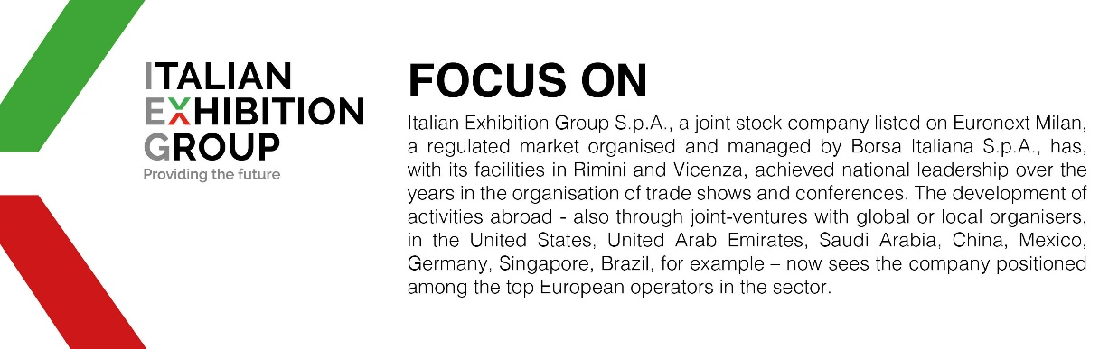

This press release contains forecast elements and estimates that reflect the management´s current opinions (´forward-looking statements´), particularly regarding future management performance, realization of investments, cash flow trends and the evolution of the financial structure. For their very nature, forward-looking statements have a component of risk and uncertainty, as they depend on the occurrence of future events. The effective results may differ (even significantly) from those announced, due to numerous factors, including, only by way of example: food service market and tourist flow trends in Italy, gold and jewellery market trends, green economy market trends; the evolution of raw material prices; general macroeconomic conditions; geopolitical factors and evolutions in the legislative framework. Moreover, the information contained in this release, does not claim to be complete, and has not been verified by independent third parties. Forecasts, estimates and objectives contained herein are based on the information available to the Company as at the date of this release.

