press release

SIGEP WORLD, THE GLOBAL EVENT FOR THE ARTISAN GELATO BUSINESS

- The 46th edition of the event organised by Italian Exhibition Group confirms its role as the global hub for the gelato business. A recognition also corroborated by top buyers in attendance in Rimini: 50% declared their interest in the gelato sector

- Great expectations for the debut of ‘Taste of Tomorrow’, a bio-architecture project for a sustainable out-of-home experience

- The Gelato Arena will be the centre of the main industry talks and national and international competitions

Rimini, 20th December 2024 – The 46th edition of SIGEP World, organised by Italian Exhibition Group and scheduled to take place from 18th to 22nd January at Rimini Expo Centre, confirms its position as the world’s most complete and innovative trade show event dedicated to the artisan gelato business.
SIGEP World attracts the entire community to Rimini, which, over the five days of the show, will be able to meet the main players on the global market, discover the latest technologies and trends, and forge new business partnerships.
The large international participation, with a special focus on the gelato sector with 50% of the over 520 Top Buyers selected by IEG in collaboration with the Italian Trade Agency and the Regional Advisor network interested in gelato, testifies to the strategic importance of SIGEP World as a reference platform for sector innovation and growth.

TASTE OF TOMORROW
In Hall A5, visitors will be able to immerse themselves in a unique installation that merges art, science and sustainability and represents a new paradigm for the out-of-home experience.
Created in collaboration with architectural firms The NE[S]T and ecoLogicStudio, the “Glacial Drip” project replicates an Alpine landscape through living, biodegradable materials. But that’s not all: thanks to algae-growing bioreactors, the installation actively captures the equivalent CO2 of 10 mature trees, purifying the air and producing an algae-based, nutrient-rich biomass.
This biomass will be used to create new and innovative gelato flavours, combining palatability and respect for the environment. SIGEPWorld 2025 demonstrates once again how the foodservice sector can be at the forefront of innovation and sustainability.
The innovative tastings will be prepared by gelato chef Sergio Colalucci, President of the Gelato World Cup.

GELATO ARENA
Hall A7 will house the Gelato Arena, the venue for the main competitions and industry talks featuring more than 60 professionals from all over the world.
Talks. The Gelato Arena will join the Vision Plaza as regards the sector’s main talks and in-depth moments with the participation of partners and associations such as Unione Italiana Food – Gelato Product Group, Acomag – Italian Association of Gelato Machinery Furnishings and Equipment Manufacturers, Artglace and the Italian Gelato Makers Association, without forgetting the presentation of the ‘Gelaterie d'Italia’ Guide by Gambero Rosso, which will award the prestigious Tre Coni prizes.
Competitions. SIGEP World 2025 will host the second edition of the Gelato Europe Cup, the competition aimed at selecting the best European teams made up of a gelato maker and a pastry chef, scheduled for Saturday 18th and Sunday 19th January. The four winners will win the right to participate in the 11th edition of the Gelato World Cup, scheduled to take place at SIGEP World 2026.
Eight nations will be competing: Albania, Belgium, France, Germany, Italy, Poland, Romania, UK.
The 2025 edition will also see collaboration with the World Association of Chefs Society - Worldchefs.
Also worthy of note is Gelato Festival World Masters, the prestigious international competition for individual gelato makers, which will see two challenges take place in Rimini: on Monday 20th January, the Germany Final, with 15 gelato makers competing for the world finals in 2026; on Tuesday 21st, the Iberian Challenge, with 16 gelato makers from Spain and Portugal vying for the European finals.
On Wednesday 22nd, SIGEP World will make room for future gelato professionals. Thanks to the competition organised by Artglace, students from hotel and catering schools will have the chance to put their skills and creativity to the test by helping to stimulate an increasingly specialised and avant-garde training offer in the gelato sector.
Numerous sponsors make it possible to stage the competitions in the Gelato Arena - Gelato Europe Cup: Platinum sponsors: Anselmi, Babbi, Electrolux; Valrhona. Golden sponsors: Adamance, Carpigiani. Silver sponsors: Caffè Toraldo, Frascheri, Medac, TeamSystem. Technical sponsors: Ico.Cialde, Ifi, Karel, Paperlynen, Reire, Sara Creazioni, Selmi, Sosa, Norohy. Media partners: Pasticceria Internazionale and PuntoIT. In collaboration with Gelato e Cultura and with the support of the In Cibum Gastronomy High School.

PRESS CONTACT SIGEP ITALIAN EXHIBITION GROUP
head of media relation & corporate communication: Elisabetta Vitali; press office manager: Marco Forcellini, Pier Francesco Bellini; press office coordinator: Luca Paganin; international press office coordinator: Silvia Giorgi; press office specialist: Nicoletta Evangelisti, Mirko Malgieri - media@iegexpo.it

MEDIA AGENCY SIGEP: Mind The Pop
Martina Vacca: martina@mindthepop.it, mob. +39 339 748 5994; Fabrizio Raimondi: fabrizio@mindthepop.it, mob. +39 335 389 848; Benedetto Colli: benedetto@mindthepop.it, mob. 380 371 2272; Stefano Chiossi: stefano@mindthepop.it, mob. + 39 388 739 4358.

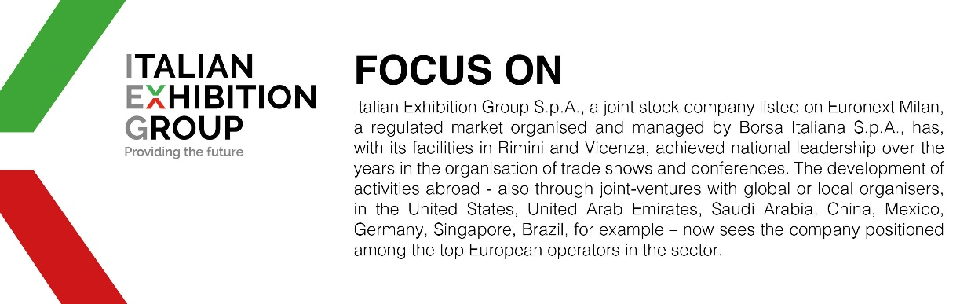

This press release contains forecast elements and estimates that reflect the management´s current opinions (´forward-looking statements´), particularly regarding future management performance, realization of investments, cash flow trends and the evolution of the financial structure. For their very nature, forward-looking statements have a component of risk and uncertainty, as they depend on the occurrence of future events. The effective results may differ (even significantly) from those announced, due to numerous factors, including, only by way of example: food service market and tourist flow trends in Italy, gold and jewellery market trends, green economy market trends; the evolution of raw material prices; general macroeconomic conditions; geopolitical factors and evolutions in the legislative framework. Moreover, the information contained in this release, does not claim to be complete, and has not been verified by independent third parties. Forecasts, estimates and objectives contained herein are based on the information available to the Company as at the date of this release.

