press release no. 3

SIGEP WORLD 2025:
HUGE BOOST FOR THE PIZZA SECTOR WITH RAW MATERIALS, INNOVATION AND TRENDS TO PROMOTE MADE IN ITALY

- Over 180 companies and 200 brands presenting innovative solutions for ingredients, equipment and technologies in the pizza industry

- Pizza Club, a new hub with show-cooking, masterclasses and the participation of more than 40 world-famous pizzeria chains

- “World Pizza Champion Games” and a focus on dessert in pizzerias: a series of events to explore the evolution of pizza, from Italian traditions to new trends

sigep.it

Rimini, 20th December 2024 – Pizza, the most exported food product in the world and symbol par excellence of Italian tradition, will be among the key players at SIGEP World - The World Expo for Foodservice Excellence, the Italian Exhibition Group event now at its 46th edition, scheduled to take place at Rimini Expo Centre from 18th to 22nd January.
Through the Pizza Tour, 180 companies will be showcased at the exhibition with over 200 brands offering the best solutions in terms of ingredients, equipment, technologies and innovative formats. From products - such as selected flours, tomato preserves, oils, top-quality dairy products - to toppings and the most innovative technologies, SIGEP World extends its exhibition offer to celebrate one of Made in Italy’s gastronomic symbols in all its many aspects. After having successfully represented the machinery and equipment sector for the Pizza industry at past editions, with the expansion of the east wing, SIGEP World is now offering the public two new halls dedicated to Pizza and Bakery to promote the entire supply chain and a full programme of initiatives and special events involving more than 40 pizzeria chains.

PIZZA CLUB: THE INNOVATIVE HEART OF SIGEP WORLD 2025
Located in Hall B8, Pizza Club is the new hub created in collaboration with AVPN-Associazione Verace Pizza Napoletana (Real Neapolitan Pizza Association), which will enable participating companies to present their products, from raw materials to the latest technologies. During the five days, Pizza Club will feature show-cooking and masterclasses led by internationally renowned chefs and pizza chefs, in-depth discussions on the most innovative techniques and high-quality ingredients, and a lively programme of events to encourage networking between companies, buyers and visitors.
The most eagerly awaited appointments include “Generazione Verace” showcooking: with the participation of star-awarded pizza makers and chefs such as Fratelli Coppola, Ciro Salvo (50 Kalò) and Giacomo Devoto; conferences on the future of training in pizzerias, artisan pizzeria chains and the socio-economic Neapolitan pizza observatory. In addition, the “Margherita e le sue sorelle” masterclass: practical sessions with world-famous pizza chefs, including Francesco Pone, Vincenzo Esposito and Fulvio Belfiore, to explore techniques and innovations regarding the product that is a symbol of Italian style.

PIZZA ARENA: THE INTERNATIONAL EVENT AND COMPETITION STAGE
The Pizza Arena will host exclusive events to promote the best of the pizza world's tradition and innovation. Two major appointments will take place here: starting on Saturday 18th January with International Pizza Show-Cooking, which will present live demonstrations by world-famous pizza chefs and pizza makers, and continuing on Sunday 19th January with International Franchising Day, dedicated to a comparison between pizzeria chains and sector professionals. Protagonists will include some of the most famous pizzeria chains: Da Michele, Errico Porzio, Koti Pizza, L'Artigiano, Menchetti, Pizzikotto, Cigierre, Pizzium, Crocca, Rossopomodoro, Rom'antica, Spontini Holding, Slice House, Fratelli La Bufala, Cocciuto, Metro Pizza, Cibiamo and Tosca.
SIGEP World will also host the “Pizza Senza Frontiere - World Pizza Champion Games” competition, organised by Ristorazione Italiana Magazine. The world's best pizza chefs will compete in 17 categories ranging from Italian tradition - classic, Neapolitan and Roman pizza - to the most creative specialities, such as dessert pizza. An exceptional jury, composed of chefs and sector professionals, will assess each creation taking into account dough, cooking, presentation and flavour balance.

DESSERT IN PIZZERIA: A TREND TO BE EXPLORED AT THE SHOW
Among the most innovative themes at SIGEP World 2025 is the focus on dessert in pizzerias, a revolution that is redefining the pizzeria experience. Originating from the evolution of the pizzeria as a convivial place for families and friends, dessert is becoming increasingly important. In the talk curated by 50 Top Pizza, entitled “Sweet Pizza and Dessert in Pizzeria”, this new trend will be explored: from the first sweet pizzas, simple fried pastries with chocolate, to recent creations that see pizza chefs experimenting with doughs and ingredients to create truly innovative desserts, such as artisan panettone and homemade gelato.

PRESS CONTACT SIGEP ITALIAN EXHIBITION GROUP
head of media relation & corporate communication: Elisabetta Vitali; press office manager: Marco Forcellini, Pier Francesco Bellini; international press office coordinator: Silvia Giorgi; press office coordinator: Luca Paganin; press office specialist: Mirko Malgieri - media@iegexpo.it

MEDIA AGENCY SIGEP: Mind The Pop
Martina Vacca: martina@mindthepop.it, mob. +39 339 748 5994; Fabrizio Raimondi: fabrizio@mindthepop.it, mob. +39 335 389 848; Benedetto Colli: benedetto@mindthepop.it, mob. 380 371 2272; Stefano Chiossi: stefano@mindthepop.it, mob. + 39 388 739 4358.

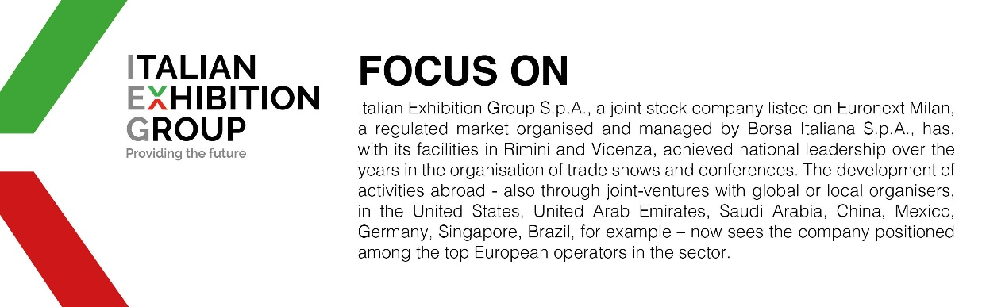

This press release contains forecast elements and estimates that reflect the management´s current opinions (´forward-looking statements´), particularly regarding future management performance, realization of investments, cash flow trends and the evolution of the financial structure. For their very nature, forward-looking statements have a component of risk and uncertainty, as they depend on the occurrence of future events. The effective results may differ (even significantly) from those announced, due to numerous factors, including, only by way of example: food service market and tourist flow trends in Italy, gold and jewellery market trends, green economy market trends; the evolution of raw material prices; general macroeconomic conditions; geopolitical factors and evolutions in the legislative framework. Moreover, the information contained in this release, does not claim to be complete, and has not been verified by independent third parties. Forecasts, estimates and objectives contained herein are based on the information available to the Company as at the date of this release.

