press release no. 7

SIGEP WORLD 2025:
TECHNOLOGY AND SUSTAINABILITY, KEY FOODSERVICE PLAYERS
- Focus on advanced and sustainable technologies for global catering thanks to partnerships with EFCEM Italia and Assofoodtec
- The catering machinery market touches on 100 billion euros; environmentally-friendly technological solutions, also with Artificial Intelligence, are a growing trend
- Innovation & Start-Up Award 2025 is back with two international awards for companies and start-ups
sigep.it

Rimini, 20th December 2024 – SIGEP World 2025 - The World Expo for Foodservice Excellence, Italian Exhibition Group’s event scheduled to take place from 18th to 22nd January at Rimini Expo Centre, will spotlight technology as a key element for the development and innovation of all the supply chains represented: Gelato, Pastry, Chocolate, Coffee, Bakery and Pizza. In this sense, SIGEP World acts as an international hub for technological innovation in Foodservice. Latest generation technologies and innovative machinery increasingly oriented towards reducing the environmental impact will be the focus of the show in response to global market challenges.

NEW PARTNERSHIPS FOR A SIGEP WORLD IN THE NAME OF TECHNOLOGY
Strategic orientation towards technologies is becoming stronger thanks to two partnerships set up with the sector’s leading Italian associations: EFCEM Italia – Catering and Hospitality Equipment Manufacturers’ Association, whose contribution will be fundamental for exploring the development of catering and hospitality industry technologies; and Assofoodtec, an association of ANIMA - Confindustria Meccanica Varia, which represents Italian manufacturers of machinery, systems and equipment for the foodservice industry, including the UCIMAC – Coffee Machine Manufacturers’ Union section, which will provide a specific focus on innovations linked to the world of coffee. According to data released by EFCEM Italia, global demand for catering equipment reached 99.7 billion euros in 2022 registering a 30% growth compared to 2020. Although 2023 and 2024 recorded a slight drop (-4% and -5% respectively), the market remains solid with volume forecasts stable for 2025. On the production front, Italy is in fourth place after the United States, China and Germany, confirming the international competitiveness of Italian industry. As regards technology, the market is facing a phase-out of machines fuelled by gas in favour of those powered by electricity, a trend that is bound to catch on in every leading global market. A technological upgrade welcomed by producers that is particularly applicable in the field of ovens, blast chillers and freezers, which are increasingly being used in food preparation and cooking procedures, and which opens the road to AI applications designed to improve the operator experience and optimise the management of cooking process information.

TECHNOLOGIES AND ENVIRONMENTS AT THE HEART OF SIGEP WORLD WITH TALKS AND PANEL DISCUSSIONS
Numerous talks and round tables will provide food for thought on ambiences and technologies with particular attention to reducing the environmental impact.
One of the Foodservice world’s hottest topics is refrigeration, the protagonist of the conference entitled “The future of refrigeration: how innovation can reduce costs and the carbon footprint” to be held on Saturday 18th January at 1.30 pm. The event will present innovative solutions, such as “technologies in the solid state”, which could eliminate the use of refrigerant gases and drastically reduce energy consumption, marking a fundamental step forward towards more sustainable refrigeration.

TECHNOLOGICAL INNOVATION IN FOODSERVICE: FROM GELATO TO PIZZA
From Gelato, with the debut of the Taste of Tomorrow project dedicated to the venue of the future and new, energy-saving machines, to Bakery, with the presentation of latest generation ovens designed to improve quality and efficiency, technological innovation will be a feature of every supply chain. In the Coffee sector, for example, technology will be at the fore with cutting-edge packaging solutions and equipment for automatic processing in the Fully Automatic Coffee Machine area. And sectors such as Pizza will see the launch of innovative equipment for faster and more sustainable processing with a focus on state-of-the-art technologies for making the world’s most loved Made-in-Italy product, from flours to cooking techniques, frozen ingredients, ready-made toppings, ovens and furnishing solutions.

INNOVATION & START-UP AWARD 2025
As confirmation of SIGEP World’s innovative DNA, the Innovation & Start-Up Award, the prestigious recognition organised by IEG in partnership with ANGI – National Association of Young Innovators and the Italian Trade Agency, is back.
The Innovation Award is specifically given to companies that represent the SIGEP World supply chains with the most advanced and innovative solutions for the Gelato, Pastry, Bakery, Coffee, Chocolate and Pizza sectors in seven categories: Best Organic / Free From Product, Digital Innovation and AI, Equipment, Technology & Kitchen Materials, Frozen & Ready-made Products, Ingredients & Semi-finished Goods, Packaging Solutions & Machinery and Sustainability. The Start-Up Award on the other hand, is for start-ups that present innovative projects able to revolutionise the Foodservice world. 22 companies will be at the show and the most curious proposals include: plant-based alternatives to cheese and natural sweeteners for food and drinks, as well as supplements for food intolerances. On the technological front, advanced software for company management and tools for research through artificial intelligence particularly stand out. There will be no shortage of creative ideas, such as edible cutlery, soot-free wood burners and digital platforms for interactive menus and sensorial analyses.

PRESS CONTACT SIGEP ITALIAN EXHIBITION GROUP
head of media relation & corporate communication: Elisabetta Vitali; press office manager: Marco Forcellini, Pier Francesco Bellini; international press office coordinator: Silvia Giorgi; press office coordinator: Luca Paganin; press office specialist: Mirko Malgieri - media@iegexpo.it

MEDIA AGENCY SIGEP: Mind The Pop
Martina Vacca: martina@mindthepop.it, mob. +39 339 748 5994; Fabrizio Raimondi: fabrizio@mindthepop.it, mob. +39 335 389 848; Benedetto Colli: benedetto@mindthepop.it, mob. 380 371 2272; Stefano Chiossi: stefano@mindthepop.it, mob. + 39 388 739 4358.

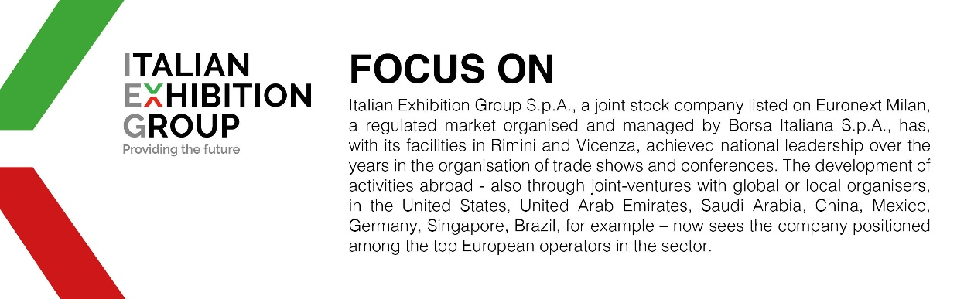

This press release contains forecast elements and estimates that reflect the management´s current opinions (´forward-looking statements´), particularly regarding future management performance, realization of investments, cash flow trends and the evolution of the financial structure. For their very nature, forward-looking statements have a component of risk and uncertainty, as they depend on the occurrence of future events. The effective results may differ (even significantly) from those announced, due to numerous factors, including, only by way of example: food service market and tourist flow trends in Italy, gold and jewellery market trends, green economy market trends; the evolution of raw material prices; general macroeconomic conditions; geopolitical factors and evolutions in the legislative framework. Moreover, the information contained in this release, does not claim to be complete, and has not been verified by independent third parties. Forecasts, estimates and objectives contained herein are based on the information available to the Company as at the date of this release.

