press release no. 8

TECHNOLOGICAL INNOVATIONS AND MARKET TRENDS:
THE FUTURE OF FOODSERVICE IS WRITTEN WITH SIGEP VISION

- High expectations for the opening talk on global trends and future scenarios for gelato and the foodservice industry. Focus also on the US and European markets thanks to partnerships with Mintel and Circana.

- Sustainability, the gelato of the future and awards for the best innovations and Start-ups will be the main projects dedicated to the sector’s future.

Rimini, 20th December 2024 – The reference point for the main market trends in the foodservice world. As well as the technological and sustainable innovations that will drive the sector in the future. Sigep Vision is the pride of the 46th edition of SIGEP World, scheduled to take place at Rimini Expo Centre from 18th to 22nd January 2025 and organised by Italian Exhibition Group. With a full programme of initiatives that integrate ideas with the physical space, Sigep Vision offers a privileged perspective on the sector’s trends. Thanks to collaborations with the sector’s leading research centres, Sigep Vision is the out-of-home industry’s global observatory, supplying trends and the latest data all year round, such as the recent report on Christmas desserts. In this way, SIGEP World confirms its tole as a reference point for sector knowledge, innovation and technology.

VISION PLAZA

Located in the South Hall, Vision Plaza will be the heart of Sigep Vision with a complete programme of panel discussions, talks and training sessions held by sector experts and opinion leaders.
There will be three main focuses: the latest market trends, technological innovations, especially linked to the world of artificial intelligence; sustainability with particular attention to ecological materials, waste reduction and ethical sourcing.
The main talks will include the following three:
- Global trends and future scenarios of the gelato and foodservice industry (Cagnoni Dome, South Hall /Saturday 18th January 2:30-3:30 pm). SIGEP World’s opening talk, moderated by Flavia Morelli (IEG’s Group Exhibition Manager Food&Beverage Division), will provide an overview of global trends and expectations for the future of gelato and the foodservice industry in general. The panel of guests will be high profile: Edurne Uranga (Vice President Foodservice Europe-Circana) will provide everyone with the sector’s very latest data in a debate that will include another three speakers: Massimiliano Zucchi (CEO of ‘La Romana dal 1947’ gelato parlour chain), Shelley Hwang (founder of Pinkberry, a US franchising with 260 dessert stores in 20 countries) and Mohammad Alsuri, Director of the Learning and Performance Department for Tazaj, the Saudi Arabian quick service restaurant chain with over 120 venues.

- Foodservice consumer and market trends: focus on the USA organised by Mintel (Cagnoni Dome, South Hall /Sunday 19th January 11-11:45 am). The presentation, organised by Ophélie Buchet, Food & Drink Associate Director for Mintel, will analyse behavioural development and consumer priorities in the US foodservice market, especially in a moment of persistent inflationary pressure. Mintel proposes three improvement areas: increase the value of perception for dishes with natural proteins and ingredients and suggest loyalty/gamification programmes; capitalise on customer interest in enjoying special treatment when eating out; balance the desire for classic experiences with the ever greater demand for convenient and speedy options.
- Outlook on the European Foodservice Industry. Future opportunities and prospects organised by Circana (Cagnoni Dome, South Hall /Sunday 19th January 3:15-3:45 pm). In this case, the focus will be on Europe thanks to an analysis proposed by Jochen Pinsker, Industry Advisor Foodservice Europe at Circana. Out-of-home consumptions in the main European countries will be outlined, identifying consumption trends and dynamics within growing rates and different contexts.
The full programme is available on the SIGEP WORLD website at this link.

ON SITE PROJECTS

In addition to the talks of reference, SIGEP Vision will provide guidelines for determining three ‘on site’ projects: Taste of Tomorrow, Sustainability District and Innovation and Start-up Award.
Taste of Tomorrow (Hall A5) aims to unite the principles of bioarchitecture to future gelato preparation. In Hall A5, visitors will be able to personally observe the visionary ‘Glacial Drip’ installation, an area with 13 bioreactors, or rather, planks of wood made with living materials on which mosses and microalgae will grow to provide a double function. Firstly, to capture the equivalent amount of CO2 of 10 large trees; secondly, to transform highly nutritious vegetable protein into a powder which will then be used as an ingredient to produce new gelato flavours.
The Sustainability District, located in Hall B1, will promote virtuous practices along the coffee and cocoa supply chains with 3 focuses: Micro Roaster Village, where micro-roasters will present their unique blends, revealing the latest trends in coffee sourcing, handling, roasting, preparation and distribution, as well as allowing visitors taste high quality coffee; Bean To Bar, where visitors will be able to immerse themselves in the world of technology and personally experience all the stages of artisan chocolate processing through workshops and guided tastings; and Fully Automatic Coffee Machinery , a selection of super-automatic coffee machines that represent the future of the sector in the name of sustainability.
The Innovation and Start-Up Award (Cagnoni Dome, South Hall) is back at SIGEP World for the second edition. A prestigious recognition – in partnership with ANGI (National Association of Young Innovators) and the Italian Trade Agency – awarded to start-ups with the most innovative products. Seven categories are awarded: Digital Innovation and AI, Equipment, Technology & Kitchen Materials, Frozen & Ready-made Products, Ingredients & Semi-finished Goods, Organic/Free From product, Packaging solutions & Machinery and Sustainability. A unique occasion to award innovations that will make the difference and to promote companies that will shape the future of the out-of-home industry.

PRESS CONTACT SIGEP ITALIAN EXHIBITION GROUP
head of media relation & corporate communication: Elisabetta Vitali; press office manager: Marco Forcellini, Pier Francesco Bellini; press office coordinator: Luca Paganin; international press office coordinator: Silvia Giorgi; press office specialist: Nicoletta Evangelisti, Mirko Malgieri - media@iegexpo.it

MEDIA AGENCY SIGEP: Mind The Pop
Martina Vacca: martina@mindthepop.it, mob. +39 339 748 5994; Fabrizio Raimondi: fabrizio@mindthepop.it, mob. +39 335 389 848; Benedetto Colli: benedetto@mindthepop.it, mob. 380 371 2272; Stefano Chiossi: stefano@mindthepop.it, mob. + 39 388 739 4358.

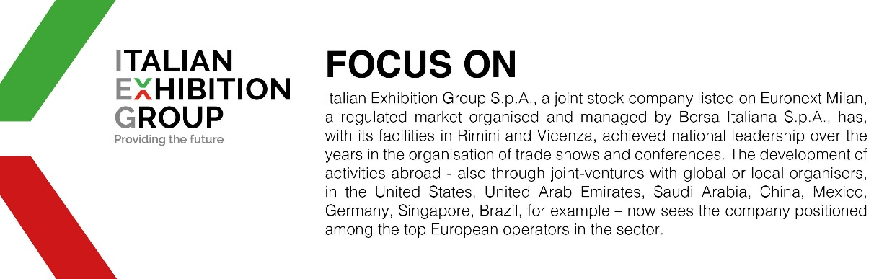

This press release contains forecast elements and estimates that reflect the management´s current opinions (´forward-looking statements´), particularly regarding future management performance, realization of investments, cash flow trends and the evolution of the financial structure. For their very nature, forward-looking statements have a component of risk and uncertainty, as they depend on the occurrence of future events. The effective results may differ (even significantly) from those announced, due to numerous factors, including, only by way of example: food service market and tourist flow trends in Italy, gold and jewellery market trends, green economy market trends; the evolution of raw material prices; general macroeconomic conditions; geopolitical factors and evolutions in the legislative framework. Moreover, the information contained in this release, does not claim to be complete, and has not been verified by independent third parties. Forecasts, estimates and objectives contained herein are based on the information available to the Company as at the date of this release.

