press release no. 9

SIGEP WORLD: EXTRA TRAINS, BUSES AND SHUTTLES

- The number of trains scheduled to arrive at Rimini Expo Centre has risen to 54 equally divided between north and south directions. Special trains also for Cattolica and Santarcangelo

- Extra buses confirmed and agreements for electric scooters and bicycles

Rimini, 20th December 2024 – This edition of SIGEP World, organised by Italian Exhibition Group from 18th to 22nd January 2025 at Rimini Expo Centre, will be extraordinary in terms of quality and quantity of exhibitor and visitor participation from every corner of the globe.

The Shuttle Italy Airport service will be running for those arriving in Ancona, Bologna and Forlì by plane with a direct connection service during the days of the SIGEP show.
Flights will, of course, not be the only option. Precisely in view of the large participation of companies and public, which will transform the city and province into the foodservice capital with an all-sold-out already announced for the exhibition halls as well as for commercial and hospitality businesses, Rimini Municipal Council and IEG, in close cooperation, have already been working for weeks to make access easier and to enhance the show in terms of visibility and economic income for the territory.

TRAINS
Train services to Rimini and the synergy with the Metromare will be fundamental for easing traffic. Heavy investments have been made to promote maximum use of the combination of transport means.
Between 8.05 and 19.29, twenty-seven northbound trains will stop at RiminiFiera and the same number of southbound trains will also stop there between 8.28 and 19.56.
A total of 54 trains will transport over 20% of the visitors to the Expo Centre and substantially all of them will stop at Rimini Central Station, allowing people to connect to the halls in less than five minutes and to conveniently access the hotels at Marina Centro and along the coast to the south using the Metromare, which connects Rimini to Riccione in 20 minutes with 15 intermediate stops.
Moreover, a Special Sigep Train will also be activated for SIGEP World 2025. Three trains will leave Cattolica railway station for Rimini Fiera during the morning and another two will leave from Santarcangelo station. In mid-afternoon, another three southbound and two northbound trains will be laid on for visitors and exhibitors. In addition to the Cattolica and Santarcangelo terminals, the trains will stop at Rimini Fiera, Rimini, Miramare, Riccione and Misano. Timetables on this link.
All information on the website www.sigep.it

METROMARE
The electric line on a specific track will ensure the transport of thousands of people a day between Rimini and Riccione. From early morning until evening, trains will run from the two terminals every 15 minutes, making management of flows generated by SIGEP World participants, operators and visitors easier to manage. The complete route takes 23 minutes with 15 stops. Timetable on this link.

EXTRA BUSES
With terminals in Santarcangelo and at the airport, Line 9 will stop in via Emilia-Fiera every 15 minutes during peak hours.
Extra services also regard the line 9 Shuttle, which IEG will organise specifically during the five days of the show in collaboration with Start Romagna. It will directly connect Rimini Fiera with the Railway Station with 22 return shuttle buses with no intermediate stops.
Linea 5, with terminals at San Mauro Mare and Rimini Fiera from the north and Line 10 in the southbound direction with terminals at Miramare and Rimini Fiera, are also available.

ELECTRIC SCOOTERS AND BICYCLES AT DISCOUNTED RATES
LIME, the electric scooter and bicycle operator, which rents vehicles via a specific App, will also be based in the district. The LIMEXFIERA code will guarantee 2 free rides a day. With the operator BIT Mobility, the App with code SIGEPBIT2025 will guarantee 20 minutes of free travel (promotion for new users). The parking areas will be at the Expo Centre’s South Entrance and inside the East 1-2, West 1-2 car parks.
Please remember that, according to the most recent highway code regulations, electric scooter users are now legally required to wear a helmet. Rented vehicles are already insured.

PRESS CONTACT SIGEP ITALIAN EXHIBITION GROUP
head of media relation & corporate communication: Elisabetta Vitali; press office manager: Marco Forcellini, Pier Francesco Bellini; press office coordinator: Luca Paganin; international press office coordinator: Silvia Giorgi; press office specialist: Nicoletta Evangelisti, Mirko Malgieri - media@iegexpo.it

MEDIA AGENCY SIGEP: Mind The Pop
Martina Vacca: martina@mindthepop.it, mob. +39 339 748 5994; Fabrizio Raimondi: fabrizio@mindthepop.it, mob. +39 335 389 848; Benedetto Colli: benedetto@mindthepop.it, mob. 380 371 2272; Stefano Chiossi: stefano@mindthepop.it, mob. + 39 388 739 4358.

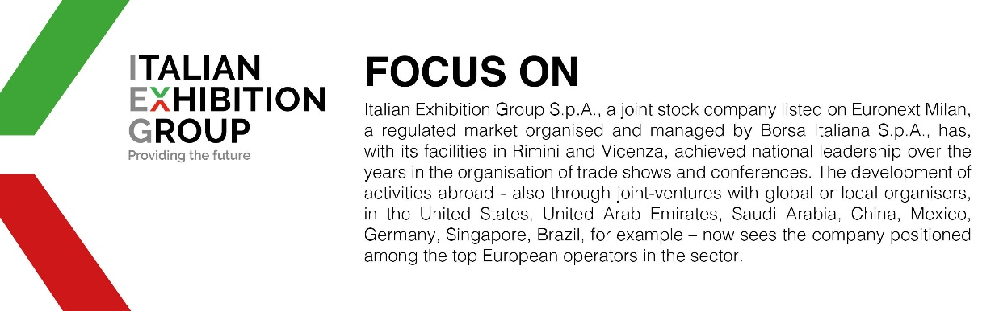

This press release contains forecast elements and estimates that reflect the management´s current opinions (´forward-looking statements´), particularly regarding future management performance, realization of investments, cash flow trends and the evolution of the financial structure. For their very nature, forward-looking statements have a component of risk and uncertainty, as they depend on the occurrence of future events. The effective results may differ (even significantly) from those announced, due to numerous factors, including, only by way of example: food service market and tourist flow trends in Italy, gold and jewellery market trends, green economy market trends; the evolution of raw material prices; general macroeconomic conditions; geopolitical factors and evolutions in the legislative framework. Moreover, the information contained in this release, does not claim to be complete, and has not been verified by independent third parties. Forecasts, estimates and objectives contained herein are based on the information available to the Company as at the date of this release.

