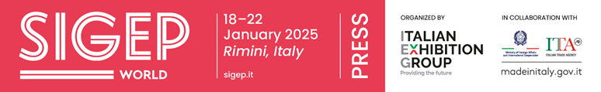

press release no. 10

THE SIGEP WORLD 2025 LAYOUT

sigep.it

Rimini, 20th December 2024 – The SIGEP World layout (Rimini Expo Centre, 18th – 22nd January 2025) reflects the supply chains represented at the show: gelato, pastry, bakery, coffee, chocolate and pizza.

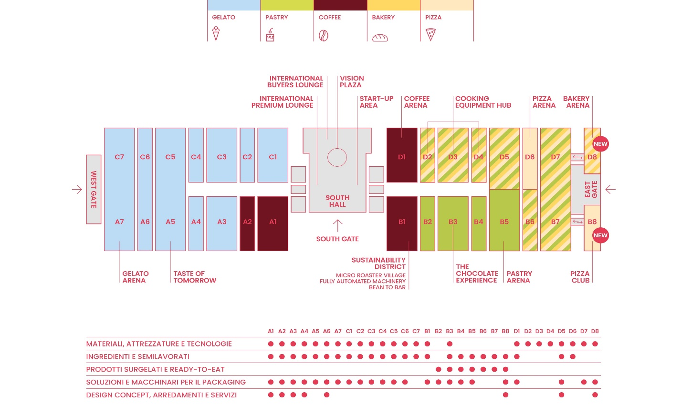

The Vision Plaza is located in the South Hall in the heart of Italian Exhibition Group’s Expo Centre and is the prime venue for the show’s training events. It hosts internationally important talks and conferences held by sector experts and opinion leaders.
The halls host leading companies operating in the ingredients, technology, furnishing, packaging, decoration and service sectors of the supply chains (Gelato, Pastry, Coffee and Chocolate, Bakery, Pizza) distributed throughout the Rimini Expo Centre: 12 halls house the gelato supply chain (from A3 to A7 and from C1 to C7); 4 host the coffee sector (A1, A2, B1, D1); 10 group together the pastry and bakery supply chain (from B4 to B7 and from D2 to D7), while halls B2 and B3 house companies from the chocolate supply chain.

The big news at Sigep World 2025 is that Rimini Expo Centre’s east wing has been extended to provide two new halls: B8 and D8 adjacent to areas B7 and D7 respectively. The two halls aim to further enhance bakery and pizza, two key sectors of the out-of-home channel.

Hall B8 will be entirely dedicated to Pizza with the new entry, the Pizza Club, the heart of dynamic activities with show-cooking and masterclasses held by world-famous pizza chefs and professionals.

Taste of Tomorrow, which will debut in Hall A5, includes the Glacial Drip, a visionary installation that redefines the out-of-home consumer experience by merging the principles of bioarchitecture with an innovative concept.

Hall B1 will house the Sustainability District which promotes sustainable practices along the coffee and cocoa supply chains, creating a direct connection between aware consumers and sustainable producers.

As of this year, the Bakery Arena will be located in Hall D8 and will host the annual appointment with the international bakery competition, Bread in the City.

The Gelato Arena, hall A7, is the theatre of highly important sector talks and will host the main international competitions, such as the Gelato Europe Cup.

The Pastry Arena, Hall B5, will hold a programme of events for high-level pastry – including the Italian Pastry Chef Championship.

The Coffee Arena, Hall D1, will see baristas and coffee professionals challenge each other in the Italian Barista Championship Area for the Barista, Brewers Cup and Cup Taster categories. These will be joined by the Italian Latte Art Championship, the Italian Coffee in Good Spirits Championship, the Italian Coffee Roasting Championship and the Cezve/Ibrik Championship.

PRESS CONTACT SIGEP ITALIAN EXHIBITION GROUP
head of media relation & corporate communication: Elisabetta Vitali; press office manager: Marco Forcellini, Pier Francesco Bellini; press office coordinator: Luca Paganin; international press office coordinator: Silvia Giorgi; press office specialist: Nicoletta Evangelisti, Mirko Malgieri - media@iegexpo.it

MEDIA AGENCY SIGEP: Mind The Pop
Martina Vacca: martina@mindthepop.it, mob. +39 339 748 5994; Fabrizio Raimondi: fabrizio@mindthepop.it, mob. +39 335 389 848; Benedetto Colli: benedetto@mindthepop.it, mob. 380 371 2272; Stefano Chiossi: stefano@mindthepop.it, mob. + 39 388 739 4358.

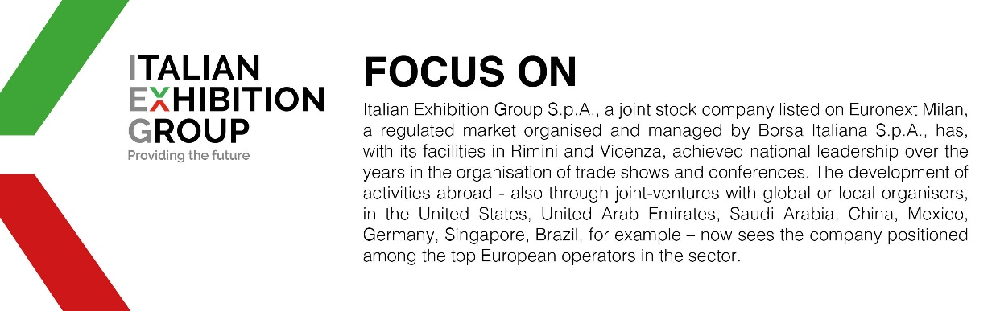

This press release contains forecast elements and estimates that reflect the management´s current opinions (´forward-looking statements´), particularly regarding future management performance, realization of investments, cash flow trends and the evolution of the financial structure. For their very nature, forward-looking statements have a component of risk and uncertainty, as they depend on the occurrence of future events. The effective results may differ (even significantly) from those announced, due to numerous factors, including, only by way of example: food service market and tourist flow trends in Italy, gold and jewellery market trends, green economy market trends; the evolution of raw material prices; general macroeconomic conditions; geopolitical factors and evolutions in the legislative framework. Moreover, the information contained in this release, does not claim to be complete, and has not been verified by independent third parties. Forecasts, estimates and objectives contained herein are based on the information available to the Company as at the date of this release.

