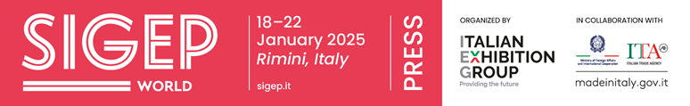
press release no. 11
FOODSERVICE, ARTISAN GELATO, PIZZA AND BREAD COMSUMPTIONS GROWING
MADE IN ITALY COFFEE MACHINE EXPORTS ALSO ON THE RISE
Rimini, 20th December 2024 – SIGEP World – The World Expo for Foodservice Excellence is ready to welcome the global foodservice industry once again and to promote the quality products with a full and varied programme of talks, exhibitions and competitions, designed specifically for professionals and companies that want to keep pace with trends and consolidate their own presence on the global market.
At Rimini Expo Centre from 18th to 22nd January 2025, the 46th edition of the Italian Exhibition Group (IEG) event will spotlight five top supply chains: gelato, pastry and chocolate, coffee, bakery and, among the big new entries, pizza. Five supply chains that represent five highly important economic sectors for the made-in-Italy foodservice industry.
Artisan gelato, growth and seasonal adjustment
In Europe, thanks to an increase of about 1% compared to 2023, traditional Italian artisan gelato sales reached 11 billion euros in 2024 (compared to 10.9 billion in 2023 and 9.83 billion in 2022). The two main markets, Italy and Germany, remained substantially stable.
The Old Continent boasts over 65,000 points of sale and about 300,000 employees: as for prices, after the 10% increase in 2023, this year the price grew by +1%, mainly due to an adjustment by the last gelato parlours that had kept their prices constant over time.
In 2024, the artisan gelato sector’s turnover grew in Italy by between 0.5% and 1% compared to 2023, touching on 3 billion euros, inclusive of gelato parlours and pastry stores and bars that offer gelato (2.9 billion in 2023 and 2.7 billion in 2022).
An Italian leadership that also regards the ingredients and semi-processed sector with 65 companies involved, a 2024 turnover of 1.1 billion euros, stable compared to 2023, and an export rate that rose to 67%. Moreover, the growth of this sector in the last decade has led to a constant increase in employment over the years and it is estimated that the number of employees, both direct and indirect (sales network), has now reached 4,000 units.
The 39,000 points of sale in Italy are subdivided into 9,235 proper gelato parlours, 12,000 pastry stores and about 18,000 bars that sell artisan gelato. The greatest concentration of artisan gelato parlours is in Lombardy where there are 1,552, equal to 16.8% of those located throughout the peninsula. Next come Veneto with 1,180 workshops, equal to 12.8% of the total, Emilia Romagna with 1,133 (12.3% of the total), Lazio with 963 (10.4% of the total), Piedmont with 778 (8.4% of the total), Tuscany with 727 workshops (7.9% of the total), Sicily with 481 (5.2% of the total) and Campania with 429 workshops, equal to 4.6% of the total.
At territorial level, the highest household expenditure for artisan gelato is in Lombardy with €315 million, followed by Lazio with €167 million, Veneto with €147 million, Emilia-Romagna with €142 million, Piedmont with €140 million, Campania with €130 million, Sicily with €121 million, Tuscany with €105 million and Apulia with €96 million.
The sector is increasingly affected by the seasonal adjustment phenomenon with over 40% of gelato parlours open all year round while the others work for no less than eight months. The summer is naturally the period of greatest consumption: around 90% of Italians consider summer to be the perfect time to buy and consume gelato. As regards frequency of purchase, 82% do so once or more a week and 68% prefer artisan products over industrial ones. As for the times of day when Italians prefer to eat gelato: they mainly prefer it as a dessert in the evening (53%), then as an afternoon snack (48%) and lastly as a dessert at the end of a meal (38%).
Master gelato makers are trying to increase consumption by broadening the consumer segment with new products that take into account the public’s new demands: in particular, “healthier” or low-glycaemic gelatos are being introduced.
(Sources: UIF, ACOMAG, AIG, Confartigianato, Confesercenti, FIPE-Confcommercio, Demoskopea, ISTAT, TCI)
Pastry: turnovers on the increase and attention to sustainability
In 2023 the trend in the artisan pastry sector was positive and basically in line with 2022. For 2024, an improvement is expected with a 4-5% growth in sales particularly due to festive pastries.
The prince of festivities is still panettone in its various versions ranging from classic to those with different fillings. In particular, classic panettone is expected to register an increase in sales of between 7 and 10% compared to 2023. Vegan and gluten-free panettones are also doing well with demand increasing by 3 and 5% respectively.
Alongside festive cakes and large leavened products, in particular (panettone and pandoro), fresh pastries and biscuit products also showed positive trends.
The artisan pastry sector is therefore holding up despite price increases mainly due to the rise in the cost of raw materials: cocoa prices have had a particular impact on chocolate products.
Italy boasts over 17,500 artisan pastry and gelato parlours employing 65,000 employees. This amounts to 20.2% of the total number of food craft enterprises. The largest number is in Lombardy (2,266), Sicily (1,803), Campania (1,694) and Veneto (1,482)
The 2024 trend for the Italian pastry industry was sustainability, towards which customers say they are increasingly attentive. More and more pastry stores are therefore committed to using local and organic ingredients. Attention is also paid to these aspects for packaging, which more and more often is being made of ecological and biodegradable materials.
(Sources: Confartigianato / Codacons)
Pizza, a sector that knew no crisis: in 2023, the overall turnover was worth 15 billion euros
In Italy, pizza, in its many versions, is still one of the favourite dishes: pizza consumption in 2023 increased by 14% compared to 2022 with a total turnover of around 15 billion euros achieved in more than 101,000 pizzerias and restaurants that also serve pizza.
The provisional results for 2024 are also in line. 50% of venues say they expect a higher turnover in 2023, while 30% believe it will be more or less at the same level as the previous year. Only the remaining 20% expect to see a decline in sales and takings.
Who is the typical pizzeria customer? 48% of patrons are families who eat pizza for dinner and, above all, at weekends. This is followed by young under 30s, who account for about one third of patrons. Almost two out of three Italians (65%) eat pizza at least once a week, but 13% do so 2 to 4 times. And pizza is increasingly attracting tourists, who account for one fifth of the total customer base.
Some 2.7 billion pizzas are baked in Italy every year, which in terms of ingredients translates into 200 million kg of flour, 225 million kg of mozzarella, 30 million kg of olive oil and 260 million kg of tomato sauce.
As far as prices are concerned, the cost of a meal in a pizzeria – inclusive of pizza, drink, cover charge and service - increased by 4% in 2024 compared to 2023 and 16% compared to 2021.
At a territorial level, the highest average cost of a pizza is €14.11 in Sassari, while the cheapest was found in Livorno at €8.70. The upper part of the ranking, but below €14, also includes Bolzano (€13.90), Milan (€13.50), and Venice (€13.47) where the highest price was also found: €24 euros for one pizza. After Livorno, the cheapest cities include Reggio Calabria (€9.15), Pescara (€9.18), Naples, where people spend an average of €9.63, Catanzaro (€9.74) and Bari (€9.75).
(Sources: CNA Agroalimentare / Coldiretti / Min. Imprese)
Bread: consumption is up but the type of demand varies
Even if consumption patterns and product type preferences change, bread is central to the Italian diet: 97% consume it habitually.
The artisan bakery and pastry sector, represented by around 46,000 companies, has a turnover of 13 billion euros: the bread sector alone is worth 8.4 billion. Preliminary figures for 2024 indicate a growth in consumption of around 1.5% in the first half of the year.
According to a trend that has been ongoing for a few years now, the choice criteria naturally change and are increasingly oriented towards healthier and more specialised products. In particular, 54.4% of consumers want an easily digestible product, 31.2% prefer it to be healthy in response to specific dietary needs or intolerances. “Free from” breads, i.e. without lactose, eggs, etc., are also on the rise. Products made with ancient cereals, unrefined or wholemeal flours, with seeds, fibres and a low glycaemic content, prepared with a lengthy leavening and eco-friendly methods, are increasingly in demand. This trend is particularly positive for the various types of bread made from wholemeal or semi-wholemeal wheat.
There is a growing demand for a diversified offer with pizzas, focaccias and bread substitutes. In Italy, the volumes of flour used in bread and bread substitute production amount to about 2.5 million tonnes, which drops to 2.25 million when considering bread alone. The quantities destined for the artisan channel are about 1.5 million tonnes. 85% of consumption is concentrated on fresh artisan bread.
(Sources: AIBI / Italmopa)
Coffee: Italian exports on the increase in 2023. The coffee machine sector is growing
About a thousand companies operate in the coffee sector in Italy, spread over the entire territory, with direct employment estimated at around 7,000 employees and an industry turnover in 2023 estimated at 5.2 billion euros, of which about 2.3 billion from export sales and 2.9 billion from domestic sales.
Roasted coffee was the fourth most exported Italian agri-food product with a turnover of 2.259 billion euros (+6.8% compared to 2022, a figure that confirms Italy as the world's second largest exporter of this product), equal to 3.5% of agri-food exports, and a volume of over 285,000 tonnes, stable compared to 2022, and driven by a particularly positive fourth quarter that recorded growth in both value (+7.3%) and volume.
By contrast, domestic consumption stagnated at 327 million kg, down 6.85% compared to 2022 due to significant price increases. Domestic consumption, supported by the retail and e-commerce channels, accounted for 71% of the total in terms of quantity, while out-of-home consumption, fuelled by the Ho.Re.Ca., Vending and OCS sectors, amounted to 29%. In terms of value, out-of-home consumption is more significant due to higher average prices compared to retail.
2023 was a good year for the coffee machine sector, one of Italy's industrial excellencies. The year closed with a turnover of over 550 million euros, up 0.9% compared to 2022. Exports, which account for more than 75% of our companies' turnover and which increased by 2.5% to 415 million euros, were also positive.
(Sources: Consorzio Promozione Caffè / UCIMAC)

PRESS CONTACT SIGEP ITALIAN EXHIBITION GROUP
head of media relation & corporate communication: Elisabetta Vitali; press office manager: Marco Forcellini, Pier Francesco Bellini; press office coordinator: Luca Paganin; international press office coordinator: Silvia Giorgi; press office specialist: Nicoletta Evangelisti, Mirko Malgieri - media@iegexpo.it

MEDIA AGENCY SIGEP: Mind The Pop
Martina Vacca: martina@mindthepop.it, mob. +39 339 748 5994; Fabrizio Raimondi: fabrizio@mindthepop.it, mob. +39 335 389 848; Benedetto Colli: benedetto@mindthepop.it, mob. 380 371 2272; Stefano Chiossi: stefano@mindthepop.it, mob. + 39 388 739 4358.

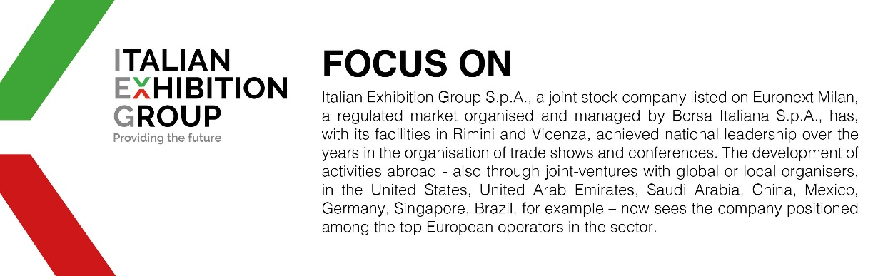

This press release contains forecast elements and estimates that reflect the management´s current opinions (´forward-looking statements´), particularly regarding future management performance, realization of investments, cash flow trends and the evolution of the financial structure. For their very nature, forward-looking statements have a component of risk and uncertainty, as they depend on the occurrence of future events. The effective results may differ (even significantly) from those announced, due to numerous factors, including, only by way of example: food service market and tourist flow trends in Italy, gold and jewellery market trends, green economy market trends; the evolution of raw material prices; general macroeconomic conditions; geopolitical factors and evolutions in the legislative framework. Moreover, the information contained in this release, does not claim to be complete, and has not been verified by independent third parties. Forecasts, estimates and objectives contained herein are based on the information available to the Company as at the date of this release.

