press release
SIGEP DAILY NEWS
Sabato 18th January 2025

CIRCANA: SPENDING ON ‘READY TO EAT’ PRODUCTS IS GROWING
Spending on ‘ready to eat’ products (that is, sold by outlets such as supermarkets and similar) rose at European level from 12.3 billion euros in 2020 to 18.1 billion euros in June 2024. And two very specific trends that emerge as a result for restaurants is leading them to re-launch themselves in an ever more crowded and competitive area: green, seeing that 44% of consumers said they were more loyal to establishments that invest in sustainability, and innovation, since 66% of Europeans are increasingly looking for restaurants that offer unique experiences. These are just some of the topics that arose during the talk “Global trends and future scenarios of the gelato and foodservice industry”, staged at SIGEP World, the international event of reference for the gelato, pastry, chocolate, coffee, bakery and pizza supply chains, organised by Italian Exhibition Group and ongoing at Rimini Expo Centre until Wednesday 22nd January. The meeting, moderated by Flavia Morelli (Group Exhibition Manager of IEG's Food & Beverage Division), featured a panel of high-profile guests: Edurne Uranga (vice president Foodservice Europe-Circana), Massimiliano Zucchi (Ceo of ‘La Romana dal 1947’ gelato parlour chain), Shelley Hwang (founder of Pinkberry, a US franchising with 260 outlets in 20 countries in the world of desserts) and Mohammad Alsuri, (director of the learning and performance department for the Saudi Arabian quick service restaurant chain Tazaj with over 120 venues), an attendance that underlines Saudi Arabia's role as guest country at SIGEP World 2025. (N.B. - photo attached)

LORENZO CAGNONI AWARD: THREE TRE START-UPS AND 21 LEADING SECTOR COMPANIES AWARDED

Today, at SIGEP World, three start-ups and 21 leading sector companies were presented with the Lorenzo Cagnoni Award, the recognition for innovative products that will create new scenarios in the international foodservice panorama. The three award-winning start-ups (from the 20 in the running) of the second edition of the initiative, organised by Italian Exhibition Group in collaboration with the Italian Trade Agency and whose main partner is ANGI-National Association of Young Innovators, were: Simply SFA, Koove and Veganok Global Srl. Innovation prizes went to MartinoRossi, Destefanis&Novero and Essenza (Best Organic/Free From product); BOB Robotics, MyFoodOffice and Cooki (Digital Innovation and AI); HOBART GmbH, MEIKO ITALIA and Ciam (Equipment, Technology & Kitchen Materials); San Giorgio, Bindi Maestri del Dessert and Mammamia (Frozen & Ready-made Products); INTERGRANI, Leagel and Galatea-Gelinova Group (Ingredients & Semi-finished Goods); Alter Eco Pulp, Alcas Spa and Imballaggi Alimentari (Packaging solutions & Machinery); Illycaffè, Julius Meinl Italia and Poloplast (Sustainability).

A NEW TECHNOLOGY FOR MECHANICAL REFRIGERATION
A new technology for mechanical refrigeration, avoiding gas compression and expansion, is ready for industrialisation. This was announced at SIGEP World by Alessandro Pastore, professor at Bologna Business and co-founder of Camfridge, a spin-off company from Cambridge University in the UK, which developed the project. The new technology will have two important benefits: reducing costs and, above all, minimising the environmental impact of a process that affects people's lives on a daily basis. A way that, according to Pastore, will revolutionise a technology that has been in use for 150 years.
GELATO EUROPE CUP: FIRST DAY OVER
The first day of the Gelato Europe Cup competitions came to a close at SIGEP World. Tomorrow, Sunday 19th January, will see the selection of the 4 teams that will qualify for the January 2026 world final of the Gelato World Cup. 8 teams from eight European countries, led by a team manager and made up of 16 of the best gelato and pastry chefs, are competing: Italy - Alessandro Racca, Gabriele Fiumara and Angelo Cardella; Germany - Stefano Lucchini, Federico Sacchet and Tiziano Santin; Albania - Rosilda Collaku, Dejvi Hajderaj Kevin Boseta; Poland - Irdi Cuka, Michal Molenda Anna, Siwiec Kaczmarczyk; UK Taseer Ahmad, Massimiliano Porta and Daniel Schevenels; France - Dartois Herve, Allan Cartignies and Enzo Babtista; Romania - Oana Gabriela Nita, Vladimir Andrei Dascalu and Morar Cornel Constantin; Belgium - Fabio Marasti, Maryne Poppe and Jose Romero

FOCUS ON SIGEP 2025
Dates: 18-22 January 2025; Organization: Italian Exhibition Group SpA; edition: 46ª; frequency: annual; event: international trade show; entry: trade only; info: www.sigep.it

PRESS CONTACT SIGEP ITALIAN EXHIBITION GROUP
head of media relation & corporate communication: Elisabetta Vitali; press office manager: Marco Forcellini, Pierfrancesco Bellini; press office specialist: Mirko Malgieri
international press office coordinator: Silvia Giorgi; media@iegexpo.it

MEDIA AGENCY SIGEP: Mind The Pop
Martina Vacca: martina@mindthepop.it, mob. +39 339 748 4994; Fabrizio Raimondi: fabrizio@mindthepop.it, mob. +39 335 389 848; Benedetto Colli: benedetto@mindthepop.it, mob. 380 371 2272; Stefano Chiossi: stefano@mindthepop.it, mob. + 39 388 739 4358.

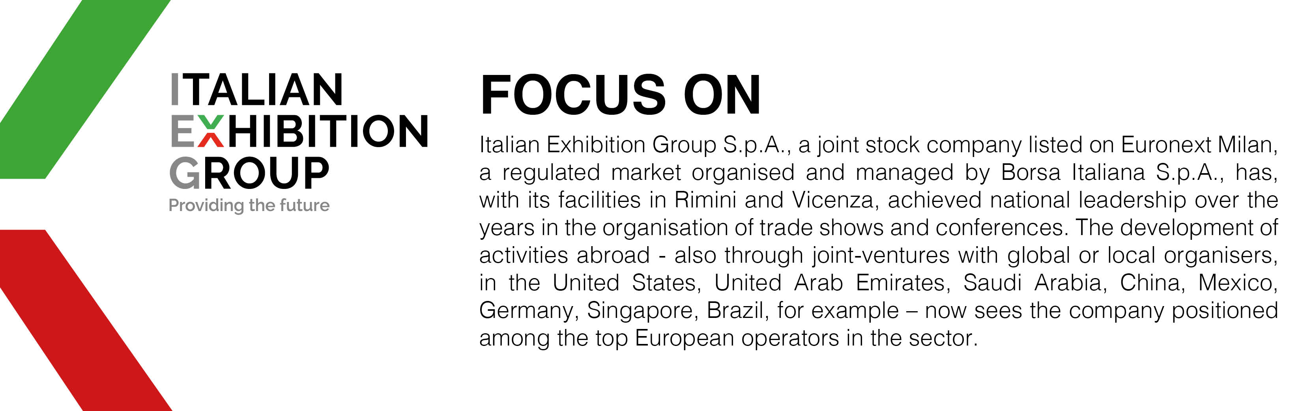

This press release contains forecast elements and estimates that reflect the management´s current opinions (´forward-looking statements´), particularly regarding future management performance, realization of investments, cash flow trends and the evolution of the financial structure. For their very nature, forward-looking statements have a component of risk and uncertainty, as they depend on the occurrence of future events. The effective results may differ (even significantly) from those announced, due to numerous factors, including, only by way of example: food service market and tourist flow trends in Italy, gold and jewellery market trends, green economy market trends; the evolution of raw material prices; general macroeconomic conditions; geopolitical factors and evolutions in the legislative framework. Moreover, the information contained in this release, does not claim to be complete, and has not been verified by independent third parties. Forecasts, estimates and objectives contained herein are based on the information available to the Company as at the date of this release.

