Press release
SIGEP DAILY NEWS-1
Sunday 19th January 2025

MINTEL ANALIZES THE LATEST FOODSERVICE TRENDS ON THE U.S. MARKET

Today, SIGEP World, organized by Italian Exhibition Group and ongoing at Rimini Expo Centre until 22nd January, staged the talk ‘Foodservice Consumer and Market Trends: Focus on the U.S.’ presented by Mintel. The focus was consumer behaviour evolution and priorities in the American foodservice market during a persistent moment of inflationary pressure. To be more precise, a Kantar Profiles/Mintel study (October 2024) revealed how 50% of those interviewed chooses to eat out in order to treat themselves to a moment of pleasure, 46% to enjoy a new experience, 38% to save time and 31% to take advantage of offers. According to Mintel, based on these data, foodservice companies can capitalize on consumers’ need for “special treatment” during out-of-home meals by using seasonal ingredients and proposing innovative combinations. Moreover, formats need to be re-invented and loyalizaton and gamification programmes need to be aimed at to try and satisfy both the search for experiences during a classic “sit-down” meal and the demand for convenient and speedy options, which are on the increase, particularly among the young.
DIGITALIZATION AND TECHNOLOGIES: THE COFFEE INDUSTRY CONTINUES TO INVEST
18% of B2B out-of-home transactions occur through digital channels. And among these, the coffee sector is one of the most technological. This was one of the trends that emerged in the talk ‘The future of coffee’ held at SIGEP World, ongoing at Rimini Expo Centre until 22nd January and organized by Italian Exhibition Group. The panel of speakers included Mario Vicentini (Comunicaffè), Cosimo Libardo (Specialty coffee association), Paolo Andrigo (Accenture), Jacopo Bambini (Cimbali), Max Fabian (European coffee federation) and Arianna Mingardi (Amigos caffè). Other sector problems were also addressed such as the decrease in arable land due to climate change, and economic instability deriving from enormous speculation with the consequent increase in prices. Fully Automatic Coffee Machines , or rather, a selection of super-automatic coffee machines that could be the sector’s future, were also given ample space. Indeed, thanks to their technology, they guarantee a consistently high performance in the cup. (N. B. – photo in attachment)
THE FUTURE OF PANETTONE: SEASONAL ADJUSTMENT AND INNOVATION
Staring off as an Italian Christmas cake, Panettone has now become a global, seasonally-adjusted product eaten all year round. A worldwide business in constant evolution with growing demand, especially in emerging markets, that is driving the industry and its artisans to innovate and satisfy increasingly demanding palates. Master chef, Giuseppe Piffaretti, creator of the Panettone World Cup, spoke of these at SIGEP World together with international master chefs such as Christophe Louie (France), Jose Romero Barranco (Spain), Andrea Besuschio (Italy), Jimmy Griffin (Ireland) and Yahei Suzuki (Japan). At Sigep World in Rimini, today and tomorrow, pastry chefs will be competing in the traditional, chocolate and, for the first time, panettone with gelato categories.

FOCUS ON SIGEP 2025
Dates: 18-22 January 2025; Organization: Italian Exhibition Group SpA; edition: 46th; frequency: annual; event: international trade show; entry: trade only; info: www.sigep.it

PRESS CONTACT SIGEP ITALIAN EXHIBITION GROUP
head of media relation & corporate communication: Elisabetta Vitali; press office manager: Marco Forcellini, Pierfrancesco Bellini; press office specialist: Mirko Malgieri
international press office coordinator: Silvia Giorgi; media@iegexpo.it

MEDIA AGENCY SIGEP: Mind The Pop
Martina Vacca: martina@mindthepop.it, mob. +39 339 748 4994; Fabrizio Raimondi: fabrizio@mindthepop.it, mob. +39 335 389 848; Benedetto Colli: benedetto@mindthepop.it, mob. 380 371 2272; Stefano Chiossi: stefano@mindthepop.it, mob. + 39 388 739 4358.

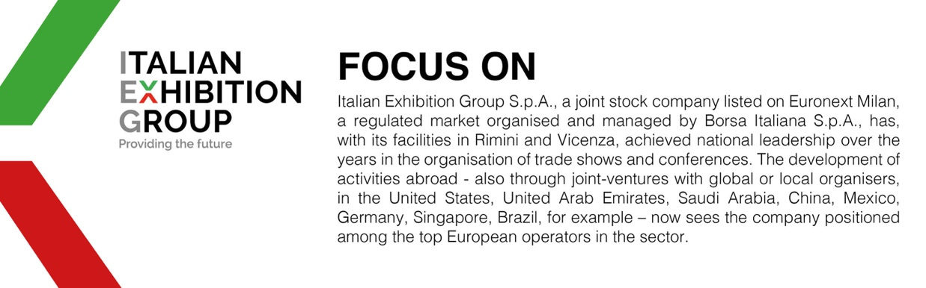

This press release contains forecast elements and estimates that reflect the management´s current opinions (´forward-looking statements´), particularly regarding future management performance, realization of investments, cash flow trends and the evolution of the financial structure. For their very nature, forward-looking statements have a component of risk and uncertainty, as they depend on the occurrence of future events. The effective results may differ (even significantly) from those announced, due to numerous factors, including, only by way of example: food service market and tourist flow trends in Italy, gold and jewellery market trends, green economy market trends; the evolution of raw material prices; general macroeconomic conditions; geopolitical factors and evolutions in the legislative framework. Moreover, the information contained in this release, does not claim to be complete, and has not been verified by independent third parties. Forecasts, estimates and objectives contained herein are based on the information available to the Company as at the date of this release.

