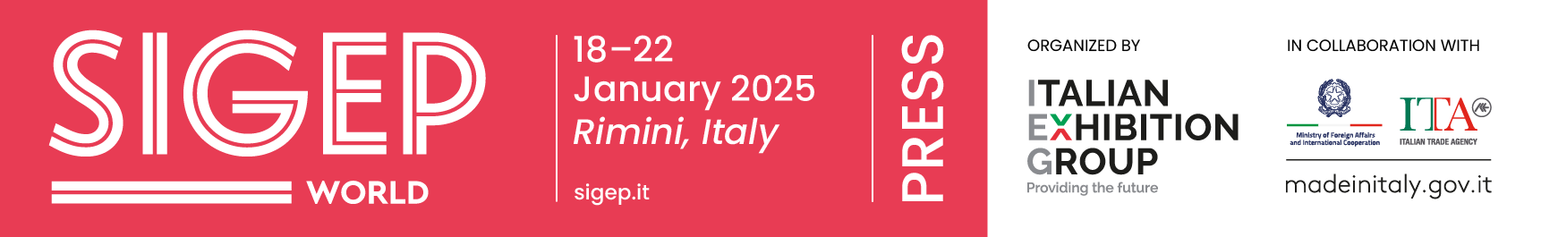
press release
SIGEP DAILY NEWS-2
Monday 20th January 2025

GUIDA GAMBERO ROSSO, THE 6 NEW GELATO PARLOURS THAT OBTAINED ‘THREE CONES’

At SIGEP World, organized by Italian Exhibition Group until Wednesday 22nd January at Rimini Expo Centre, Gambero Rosso presented the ninth edition of the Guida Gelaterie d'Italia (Italian Gelato Parlour Guide), produced in collaboration with Orion. As many as 599 gelato parlours were assessed, up from 550 last year. The list for the Three Cones - the highest recognition in terms of excellence – has also been lengthened, rising to 72, with six new entries well distributed throughout the country. The six new entries are: Gelato Contadino (Bergamo), Mille (Verolanuova, Brescia), Maritozzi e Gelato di Barbara e Renato (Bologna), Gelato Crispini (Spoleto), Mokambo (Ruvo di Puglia, Bari), and La Cremeria Vitaro (Rende, Cosenza) The Special Awards categories have also become six: emerging gelato maker, supply chain enhancement, sustainability, best gastronomic gelato, best chocolate gelato and best cream gelato.

ARTISAN PIZZA CHAINS, A FAST-GROWING PHENOMENON
Artisan pizza chains are the new trend of the moment and are establishing themselves as a fast-growing reality. This was reiterated during the talk 'Artisan Pizza Chains: from New Trend to Established Reality' staged at SIGEP World and organised by the Neapolitan Verace Pizza Association. The guest panel included Mirko D'Agata (AVPN School Montreal), Nicola Taglialatela (Peperino restaurant), Paolo Vitaletti (Peppina restaurant) and Antonio Belardo (NAP). According to the talk, several important names in the pizza universe have decided to invest, respecting the concept of product craftsmanship and studying the not easy concept of replicability.
FOCUS ON SIGEP 2025
Dates: 18-22 January 2025; Organization: Italian Exhibition Group SpA; edition: 46th; frequency: annual; event: international trade show; entry: trade only; info: www.sigep.it

PRESS CONTACT SIGEP ITALIAN EXHIBITION GROUP
head of media relation & corporate communication: Elisabetta Vitali; press office manager: Marco Forcellini, Pierfrancesco Bellini; press office specialist: Mirko Malgieri
international press office coordinator: Silvia Giorgi; media@iegexpo.it

MEDIA AGENCY SIGEP: Mind The Pop
Martina Vacca: martina@mindthepop.it, mob. +39 339 748 4994; Fabrizio Raimondi: fabrizio@mindthepop.it, mob. +39 335 389 848; Benedetto Colli: benedetto@mindthepop.it, mob. 380 371 2272; Stefano Chiossi: stefano@mindthepop.it, mob. + 39 388 739 4358.

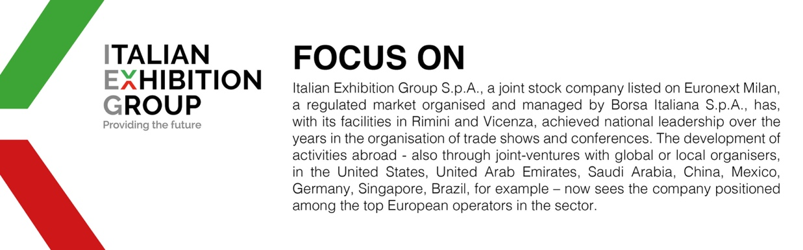

This press release contains forecast elements and estimates that reflect the management´s current opinions (´forward-looking statements´), particularly regarding future management performance, realization of investments, cash flow trends and the evolution of the financial structure. For their very nature, forward-looking statements have a component of risk and uncertainty, as they depend on the occurrence of future events. The effective results may differ (even significantly) from those announced, due to numerous factors, including, only by way of example: food service market and tourist flow trends in Italy, gold and jewellery market trends, green economy market trends; the evolution of raw material prices; general macroeconomic conditions; geopolitical factors and evolutions in the legislative framework. Moreover, the information contained in this release, does not claim to be complete, and has not been verified by independent third parties. Forecasts, estimates and objectives contained herein are based on the information available to the Company as at the date of this release.

