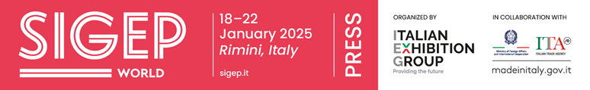
press release
SIGEP DAILY NEWS-2
Tuesday 21st January 2025
THE SOCIO-ECONOMIC OBSERVATORY OF NEAPOLITAN PIZZA IS BORN
There are more than 40,000 pizzerias In Italy (of which 10% in Naples) with a turnover of 4 billion euros and more than 300,000 employees. This sums up the Italian figures for the sector and is why the Socio-Economic Observatory of Neapolitan Pizza has just been set up with the aim of providing a complete overview of the pizza sector. The new initiative was launched at SIGEP World at a special talk entitled ‘The Economic Observatory of Neapolitan Pizza’ attended by Sergio Auricchio (General Manager of the Neapolitan Verace Pizza Association), Rocco Agrifoglio (University of Naples) and Massimo Di Porzio (President of Confcommercio Campania), who, together with Fipe, support the Observatory. Guidelines were set out during the talk: the economic, business, social/cultural and technology dimensions. A veritable reference point for pizza from which to obtain up-to-date data and, of course, comments, thanks to the support of the Observatory's partners.
RONERO MASTER, JULIO ENRIQUE AYAN RIAL, UNESCO INTANGIBLE HERITAGE, PRESENTED COFFEE AGED IN HISTORIC RUM BARRELS
BioCubaCaffè offered a unique experience that celebrated the culture of three top products: rum, coffee and chocolate. The protagonist of the event was Julio Enrique Ayan Rial, one of nine Ronero Masters recognised by UNESCO as an Intangible Heritage of Humanity. During the tasting, the first coffee aged in historical rum barrels, born from collaboration with CubaRon, was presented. Thanks to the historic ronera don Pancho’s over 50-year-old barrels, the skill of Rial and the coffeliers of BioCubaCaffè, it was possible to create a product in which the wood and rum blend perfectly with the coffee. BioCubaCaffè, a joint venture between GAF (Cuba), the Giuseppe and Pericle Lavazza Foundation ETS and HEI srl, continues to promote Cuban organic coffee through a fair and sustainable supply chain to enhance local producers and encourage integrated community development.

FOCUS ON SIGEP 2025
Dates: 18-22 January 2025; Organization: Italian Exhibition Group SpA; edition: 46th; frequency: annual; event: international trade show; entry: trade only; info: www.sigep.it

PRESS CONTACT SIGEP ITALIAN EXHIBITION GROUP
head of media relation & corporate communication: Elisabetta Vitali; press office manager: Marco Forcellini, Pierfrancesco Bellini; press office specialist: Mirko Malgieri
international press office coordinator: Silvia Giorgi; media@iegexpo.it

MEDIA AGENCY SIGEP: Mind The Pop
Martina Vacca: martina@mindthepop.it, mob. +39 339 748 4994; Fabrizio Raimondi: fabrizio@mindthepop.it, mob. +39 335 389 848; Benedetto Colli: benedetto@mindthepop.it, mob. 380 371 2272; Stefano Chiossi: stefano@mindthepop.it, mob. + 39 388 739 4358.

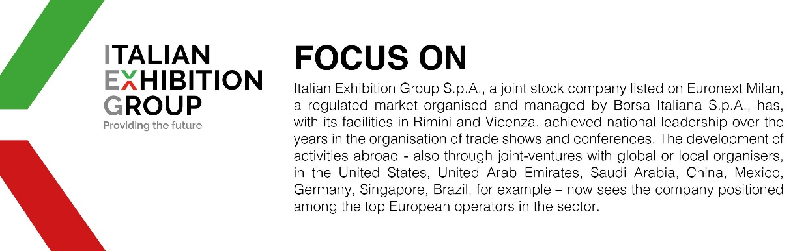

This press release contains forecast elements and estimates that reflect the management´s current opinions (´forward-looking statements´), particularly regarding future management performance, realization of investments, cash flow trends and the evolution of the financial structure. For their very nature, forward-looking statements have a component of risk and uncertainty, as they depend on the occurrence of future events. The effective results may differ (even significantly) from those announced, due to numerous factors, including, only by way of example: food service market and tourist flow trends in Italy, gold and jewellery market trends, green economy market trends; the evolution of raw material prices; general macroeconomic conditions; geopolitical factors and evolutions in the legislative framework. Moreover, the information contained in this release, does not claim to be complete, and has not been verified by independent third parties. Forecasts, estimates and objectives contained herein are based on the information available to the Company as at the date of this release.

