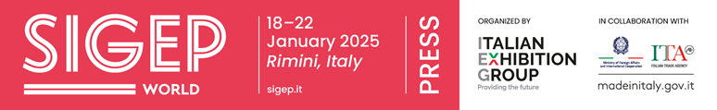
press release
SIGEP DAILY NEWS
Wednesday 22nd January 2025
GELATO DAY, VINCENZO SQUATRITO CREATES THE ‘HALLELUJAH’ FLAVOUR WITH ROASTED HAZELNUTS AND CHOCOLATE
Gianduia with toasted hazelnuts, mottled with pure chocolate. The much-awaited flavour of the year ‘Hallelujah’, the star recipe of Gelato Day 2025 dedicated to the Jubilee, was announced at SIGEP World, the event organised by Italian Exhibition Group at Rimini Expo Centre, which comes to a close today. The flavour was created by Vincenzo Squatrito from ‘Ritrovo Orchidea’ in Olivieri (Messina) in a contest that saw as many as 30 master gelato makers from all over Europe competing at SIGEP World. Gelato Day 2025, as we know, is scheduled for this coming 24th March. Advocated by Longarone Fiere and Artglace, the European Parliament has dedicated it exclusively to a food recognised as the heritage of the entire supply chain and it is sponsored by the Ministry for Evangelisation and Masaf (Minister for Agriculture, Food Sovereignty and Forestry). And thanks to the contest, ‘Hallelujah’ will be available in all European gelato parlours taking part in Gelato Day.
VINCENZO LA MONICA TRIUMPHS IN THE ITLIAN PASTRY CHAMPIONSHIP
Vincenzo La Monica triumphs in the Italian Pastry Championship, the competition staged at SIGEP World, in partnership with Conpait, which saw the best Italian over-21 talents compete on the theme ‘Sustainable Cocoa: from bean to dessert in a circular economy’. La Monica, 22, from Venetico (Messina) won first place ahead of runner-up Francesco Marchitto, 25, from Bientina (Pisa) and 24-year-old Gianluca Schettino (Massa Lubrense, Naples), who finished third on the podium. During the two-day competition (20th and 21st January), the 8 contestants competed in tests such as making 15 chocolates, 3 chocolate cakes with an obligatory crunchy meringue, and 1 artistic sugar sculpture.
COFFEE ARENA: THE WINNERS OF CILA - ITALIAN LATTE ART CHAMPIONSHIP AND THE ITALIAN COFFEE ROASTING CHAMPIONSHIP

25-year-old Stefano Cevenini from Bologna, is the 2025 winner of CILA - Italian Latte Art Championship, the sector's competition of reference staged at SIGEP World. Second and third places went to Alessio Panero, 25, from Turin, and Michele Intravaia, 34, from Canicattini Bagni (Syracuse). The championship is valid for the WLAC (World Latte Art Championship).
The Italian Coffee Roasting Championship was also held yesterday at SIGEP World, which saw 46-year-old Gianluca Lavacca from Bari triumph. The silver medal went to Emanuele Tomassi, 57, from Aprilia (Latina), and the bronze to Michael Angelini, 33, from Ascoli. The championship is valid for the WCRC (World Coffee Roasting Championship).

COMUNICANDO PRIZE 2025: FRUCTITAL WINS ‘UNICA 2024’ WITH THE BEST COMMUNICATION CAMPAIGN

Yesterday, SIGEP World staged the 18th edition of the Comunicando Prize, organised by Editrade publishing house, which celebrates the best advertising campaigns in the pastry and gelato sectors.
The Unica 2024 award, dedicated to excellence in communication, groups all the categories in the competition and was awarded to Fructital for its “Let's trace the path to your success together” campaign.
In the Best Copy category, ICO Cialde with the claim “Think small but taste big”, IPSA with “15 head-turning flavours”, Mediac with “Paper talks” and Mec3 with “Chance makes for savoury gelato”, were all on an equal footing. In the Best Visual category, prizes went to Pernigotti Maestri Gelatieri Italiani for “Piedmontese specialities”, Disaronno Ingredients for “We learn from nature”, Taddia with “For gelato artists” and Elenka with “From noble ingredients the authentic taste of tradition”. In the Best Creativity category, awards went to Giuso with “Splendidee”, PreGel with its Kung Fu Panda-inspired campaign entitled “Legend tells of a gelato that grants Kung Fu skills”, Cartoprint with “Authentic ties” and Disìo with “Tiramisud holiday destination”. Awards for the Digital Strategist 2024 category went to Martini Gelato, Carpigiani, Mec3 and Babbi for demonstrating excellence in digital strategies. There was no shortage of Special Prizes awarded to social and artistic initiatives. Winners included Ciam with the Moon Project, Disaronno Ingredients with its campaign to support the “pink” charity month for cancer prevention, and Frigomat for its support for Medecins Sans Frontieres. Three Communication Ambassadors were also appointed during the ceremony: Angelo Grasso, known for the “1000 Courses” project, Ana Maria Soto Escobar, winner of the Gelato Day 2024 Contest, and Domenico Belmonte, president of Artglace.

FOCUS ON SIGEP 2025
Dates: 18-22 January 2025; Organization: Italian Exhibition Group SpA; edition: 46th; frequency: annual; event: international trade show; entry: trade only; info: www.sigep.it

PRESS CONTACT SIGEP ITALIAN EXHIBITION GROUP
head of media relation & corporate communication: Elisabetta Vitali; press office manager: Marco Forcellini, Pierfrancesco Bellini; press office specialist: Mirko Malgieri
international press office coordinator: Silvia Giorgi; media@iegexpo.it

MEDIA AGENCY SIGEP: Mind The Pop
Martina Vacca: martina@mindthepop.it, mob. +39 339 748 4994; Fabrizio Raimondi: fabrizio@mindthepop.it, mob. +39 335 389 848; Benedetto Colli: benedetto@mindthepop.it, mob. 380 371 2272; Stefano Chiossi: stefano@mindthepop.it, mob. + 39 388 739 4358.

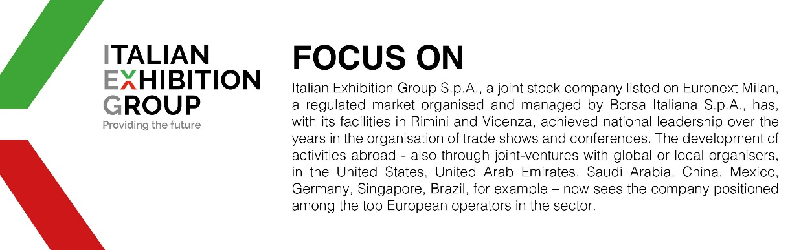

This press release contains forecast elements and estimates that reflect the management´s current opinions (´forward-looking statements´), particularly regarding future management performance, realization of investments, cash flow trends and the evolution of the financial structure. For their very nature, forward-looking statements have a component of risk and uncertainty, as they depend on the occurrence of future events. The effective results may differ (even significantly) from those announced, due to numerous factors, including, only by way of example: food service market and tourist flow trends in Italy, gold and jewellery market trends, green economy market trends; the evolution of raw material prices; general macroeconomic conditions; geopolitical factors and evolutions in the legislative framework. Moreover, the information contained in this release, does not claim to be complete, and has not been verified by independent third parties. Forecasts, estimates and objectives contained herein are based on the information available to the Company as at the date of this release.

